|  |  |
| --- | --- |
| **Professional Readiness for Innovation,**  **Employability, and Entrepreneurship**       |  | | --- | | **PROJECT REPORT** |       **Title** **:** AI Based Discourse for Banking Industry  **Team ID** **:** PNT2022TMID42387  **Industry mentor** **:** Durga Prasad  **Faculty mentor** **:**V G Karthiga  **Team Leader** **:** Jilin Antony (710419104017)  **Members** **:** Rose Mary Santhosh (710419104036)  : R P Santhosh (710419104041)  : R Vijayalakshmi (710419104060)  i |

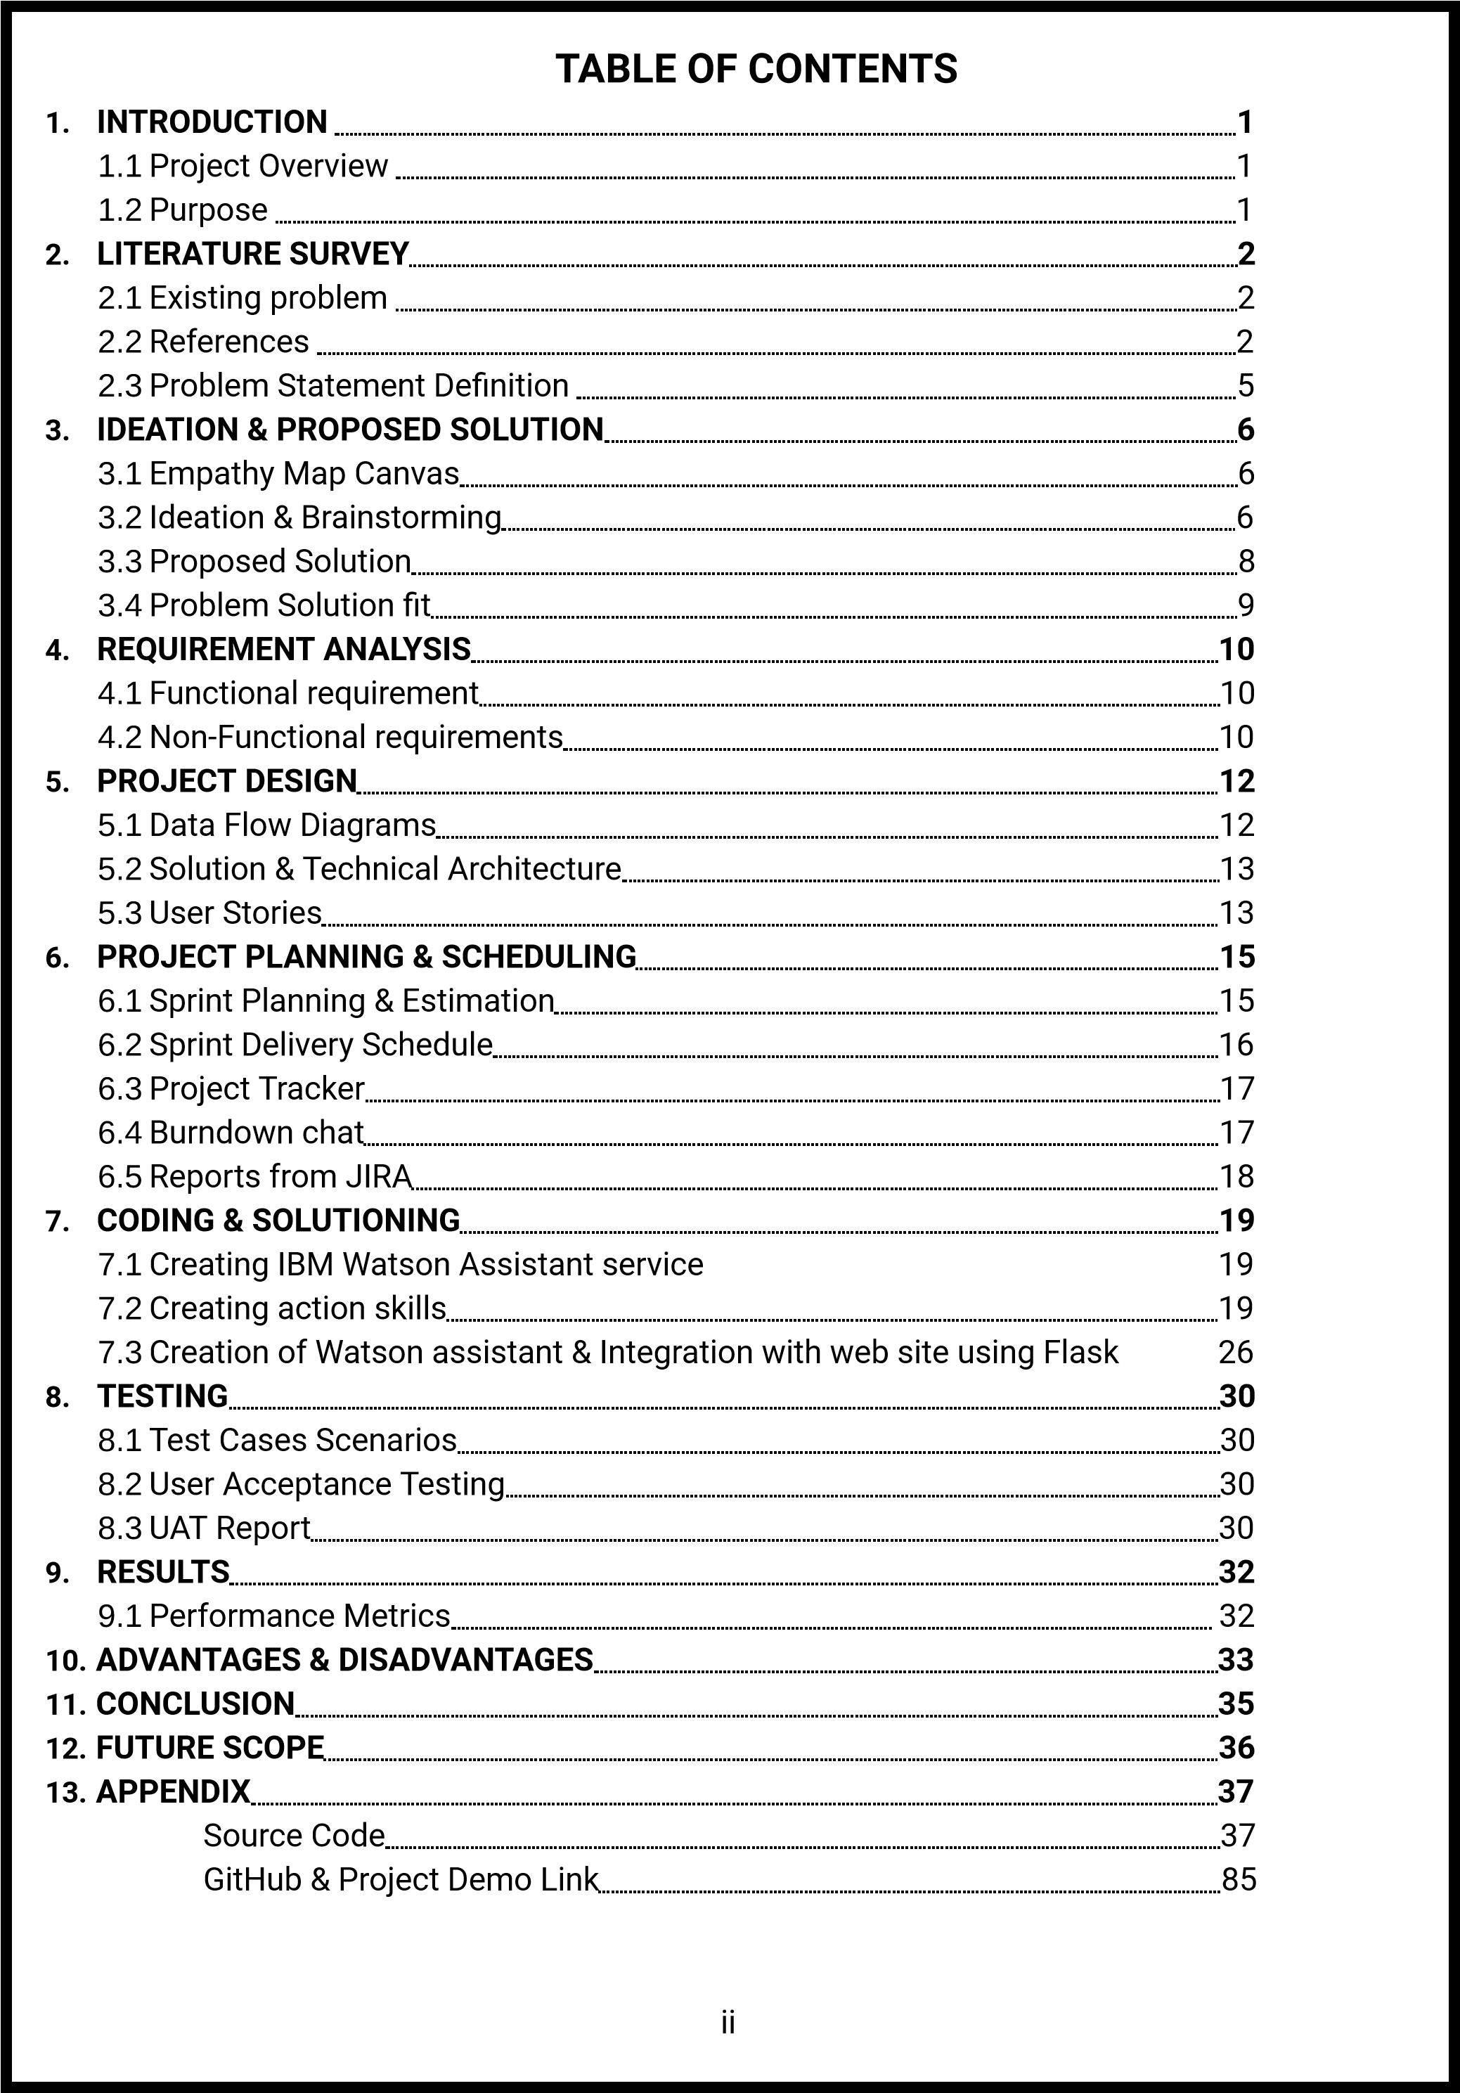

# 1.INTRODUCTION

1.1 Project Overview

A language unit longer than a single sentence is referred to as a discourse in linguistics. The Latin prefix dis-, which means "away," and the root word currere, which means "to run," are the sources of the word discourse. Thus, the word discourse, which means "run away," alludes to how talks flow. To enable a conversation between a human and computer we use Artificial intelligence to understand the natural language and reply with generation of natural language from the facts it knows. This AI discourse is enabled using chatbot. This project aims to deploy an AI based discourse in the field of Banking industry to provide 24*7 confidential, secure and personalized service

1.2 Purpose

A chatbot is much more than a straightforward conversational agent. They can link to different APIs, allowing them to, for instance, respond to a greater range of customer requests. They can also automate time-consuming processes like emailing potential clients and consumers, responding to frequently asked questions, and many more.

Chatbots can replace human agents in some jobs, which helps businesses increase sales. Because they offer excellent customer care and first-rate support, banks and other financial businesses can attract new customers using chatbots.

Customers can easily complete any financial transaction via text or voice with the aid of a chatbot for banking. Additionally, chatbots have greatly increased customer satisfaction.

AI chatbots automate about 90% of bank interactions (internal and external).

Therefore, there is a need for an AI-based chatbot that can quickly respond to customer inquiries and should be simple to use.

# 2.LITERATURE SURVEY

2.1 Existing problem

The modern market and technology advancements drive industries to change and modernize their procedures. One of the most developed industries is banking, which is constantly seeking the newest technical advancements to boost productivity. As techsavvy customers become more prevalent, more banking institutions are launching chatbot solutions using artificial intelligence to cut expenses. Finding the information, we need on net banking websites requires scrolling through numerous pages. When speaking with clients directly, bank employees encounter several difficult circumstances. Chatbots can be used to gracefully avoid such circumstances. When requesting a service from a financial institution in the past, such as withdrawing money from a bank account, the customer was often forced to fill out a form or use the screens on an ATM, tasks that they had to comprehend and carry out on their own. For those who are not familiar with such methods, this can be challenging.

Just like every other technology that reign the current era, chatbots have some minor issues with implementation in the Banking industry. Some of the problems in implementing chatbot for banking are

* One of the major drawbacks of chatbots is that they may struggle to assist when a customer's question is unclear or too detailed. If a customer asks a question that is not on this limited list of questions that can be answered by a chatbot, the bot is likely to become confused and either go around in circles while attempting to understand the question (often to no avail), or simply leave them hanging without providing an answer. In either situation, the customers won't have a positive experience, and the business' reputation could suffer.
* Chatbots were developed to respond to straightforward inquiries that can be addressed with information. Due to their limited response capacity, chatbots are frequently unable to respond to questions that require multiple parts or a decision.
* To ensure that chatbots are providing the customers with accurate information and accurately portraying the banking, they need to be optimized frequently. You'll need to update the bot as user demand and company goals change, which calls for analyzing previous bot conversations to discover the most frequent queries the bot encounters.

2.2 References

1. **Title**: A Review of Chatbots in the Banking Sector

**Author**: Shashank Bairy R and Rashmi R

**Published year:** 2021

**Description**: This paper explains the basic anatomy of the chatbots and the various applications of the chatbots in banking sector. It also went over various improvements that could be made on the current chatbot technologies. It states that the role of chatbots play in the banking sector will only continue to raise due to the constant improvements being made to its logic and increased demand among the customer for better experience.

1. **Title**: Dialogue AI for Financial Services

**Author**: Takeshi Shirai, Masaaki Yamamoto, Ph.D., Yu Asano, Ph.D., Yusuke Fujita and Katsuyuki Tsunami

**Published year:** 2018

**Description**: By examining the challenges faced by current chatbots and the strategies being used to solve them, this article describes the technologies and features that future dialogue AIs will require in order to be effective business applications of dialogue AI in banking institutions. Dialogue AI has the ability to be used in a variety of different formats and different business settings, going beyond its current function as a straightforward user interface.

1. **Title**: An Ontology-Based Dialogue Management System for Banking and Finance Dialogue Systems

**Author**: Duygu Altinok

**Description**: Keeping the dialogue state in dialogue systems is a notoriously difficult task. So this paper introduce an ontology-based dialogue manager (OntoDM). With this new framework the author addresses the dialog management. It describes domain-driven ways to keep the conversation memory, both the user and the bot side, make the anaphora resolution, generate knowledge-based answers, possibly contribute to what to say next, integrate linguistic features into the context NLU but answer generation modules were considered in detail in this paper.

1. **Title**: CHATBOTS IN BANKING INDUSTRY: A CASE STUDY

**Author**: Dr. Shalini Sayiwal

**Published year:** 2020

**Description**: The about paper states regarding the banking industry and the technology has provided several unique ways to enable the sector to maximize consumer happiness. Introducing chatbots to its clients is one such clever tactic. One of a bank's most promising business techniques that can help it win the loyalty of its devoted consumers is the use of chatbots created using AI. This paper examines about the pros and cons of the existing Chatbots names EVA (Electronic Virtual Assistant) of HDFC (Housing Development Finance Corporation Limited) and Keya of Kotak Mahindra Bank.

1. **Title**: Conversation to Automation in Banking Through Chatbot Using Artificial Machine Intelligence Language

**Author**: Sasha Fathima Suhel, Vinod Kumar Shukla, Sonali Vyas and Ved Prakash Mishra

**Published year:** 2020

**Description**: The paper demonstrates how AI is always evolving. This study introduces a novel idea that discusses machine intelligence and highlights the possibilities of intelligent systems. The latest disruptive force that has altered how customers connect is the growth of chatbots in the finance industry. Artificial intelligence has transformed the way that banks communicate with their consumers in the banking sector by enabling chatbots. Any nation's development depends heavily on the banking industry. It also investigates the chatbot's current usability to determine whether it can satisfy customers' fluctuating needs.

1. **Title**: Survey of Conversation to Automation in Banking Through Chatbot using Artificial Machine Intelligence Language

**Author**: Asst. Prof. Veena M Naik and Sandhya Shree

**Published year:** 2022

**Description**: The above study mentions the advent of chatbot and it also examines the efficacy of chatbots now to see if they can accommodate clients' shifting needs. This paper also states about the Artificial Linguistic Internet Computer Enterprise A.L.I.C.E (Foundation of Artificial Intelligence, 2007). It proposes ontology-based solutions for addressing conversation in the banking and financial industry.

1. **Title**: AI-based Chatbot Service for Financial Industry

**Author**: Takuma Okuda and Sanae Shoda

**Published** year: 2018

**Description**: In this paper the authors discussed about Financial Services Solution by FUJITSU, Finplex Robot Agent Platform is an AI-based business chatbot solution (also known as FRAP). By allowing customers to communicate with a robot that has knowledge amassed through machine learning, FRAP achieves automatic robot support of financial-product sales and customer service. The developments in corporate chatbot services and some examples of how to use chatbots in business applications are first covered in this article. After that, it provides a case study of Sony Bank Inc.'s use of FRAP and outlines its features.

1. **Title**: Text-Based Chatbot in Financial Sector: A Systematic Literature Review

**Author**: Hana Demma Wube, Sintayehu Zekarias Esubalew, Firesew Fayiso Weldesellasie and Taye

Girma Debelee

**Published year:** 2022

**Description**: This study gives a thorough, systematic analysis of the literature of papers on textbased chatbots in the banking industry. It discusses the understanding of chatbots in the financial sector in terms of implementation, adoption intention, attitude toward use, and acceptance; it also discusses how people perceive, expect, and trust chatbots, as well as how they are engaging and emotionally motivated; management of the security and privacy vulnerabilities of the chatbots; and it identifies potential strategies that can impede the effective, successful use of chatbots. Finally, the key findings on the use of text chatbots in the financial industry are given. In addition, the unresolved problems in the existing study are noted, and a number of future research avenues are recommended.

1. **Title**: Development of Dialogue Management System for Banking Services

**Author**: Samir Rustamov, Aygul Bayramova and Emin Alasgarov

**Published year:** 2021

**Description**: In the paper, the main two components of dialogue management systems—NLU and Dialogue Manager—have been investigated. In the first step of NLU, they utilized the Language Identification component for language detection with both built-in LI methods such as fastText and custom ML models trained on the domain-based dataset. The second step of the work was the comparison of the classic ML classifiers and DIET architecture for the user intention detection. Four different ML algorithms with nine various features are trained with 36 different models. The Dialogue Management module is then trained by transformer embedding dialogue policy.

1. **Title**: Chatbot for Healthcare System Using Artificial Intelligence

**Author**: Lekha Athota, Vinod Kumar Shukla, Nitin Pandey and Ajay Rana

**Published year:** 2020

**Description**: The paper's primary goal is to provide visitors with basic health information. When a person initially accesses the website, they must register before they may ask the bot questions. If the answer is not found in the database, the system employs an expert system to respond to the requests. Domain experts are also required to register by providing certain data. The chatbot's data is kept in the database as pattern-template data. Here, the database is managed through SQL.

2.3 Problem Statement Definition

Conversational Banking is a smarter way to retain the loyal customers by offering them a quick response to their queries. But the problem is to train the bank employees to get absolute knowledge to answer every query and having good skills of handling customers. Moreover, the employees can’t provide 24*7 secure and reliable service. So, we have to develop an AI based chatbot that could answer the customers query immediately which should be easy to use.

# 3.IDEATION & PROPOSED SOLUTION

3.1 Empathy Map Canvas

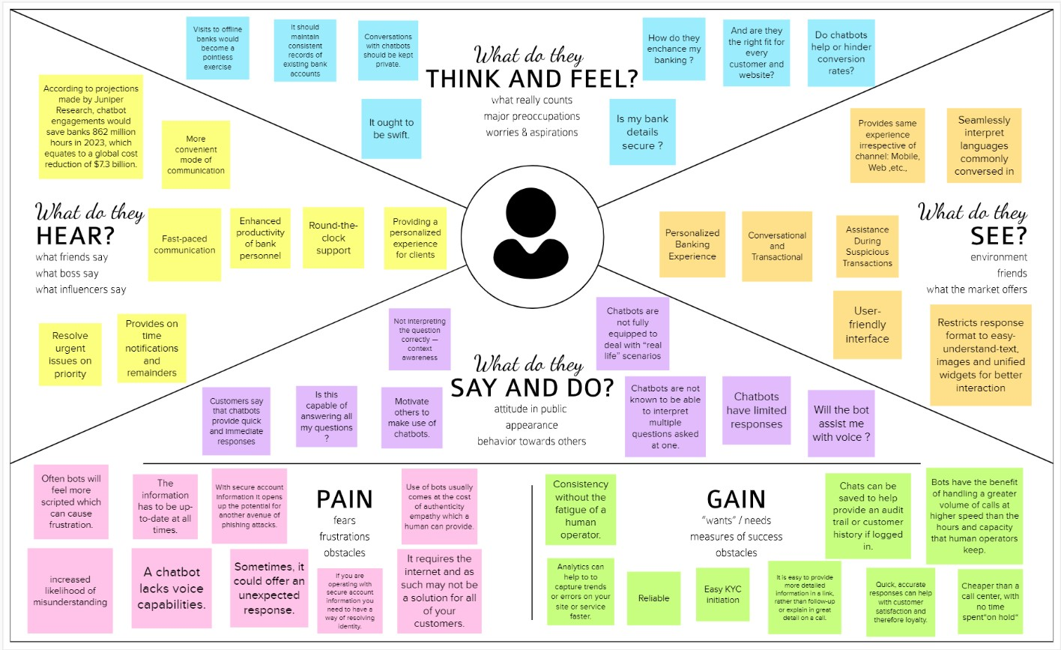

3.2 Ideation & Brainstorming

**Step-1: Team Gathering, Collaboration and Select the Problem Statement**

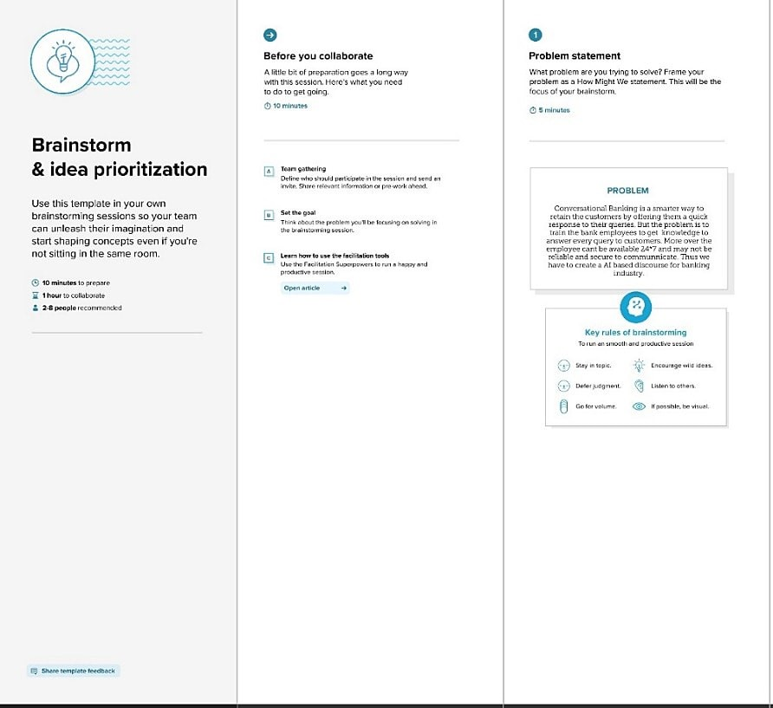

**Step-2: Brainstorm, Idea Listing and Grouping**

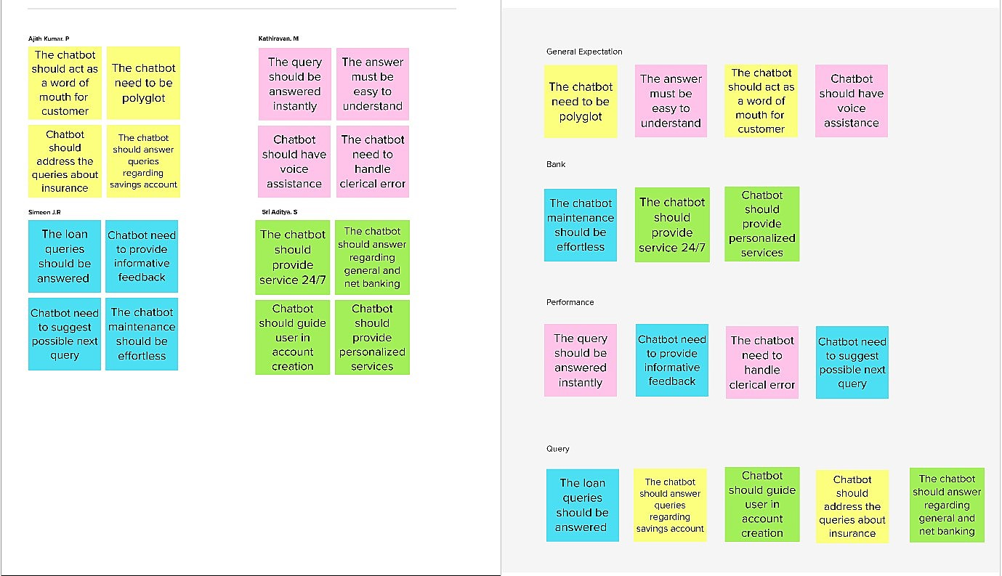

**Step-3: Idea Prioritization**

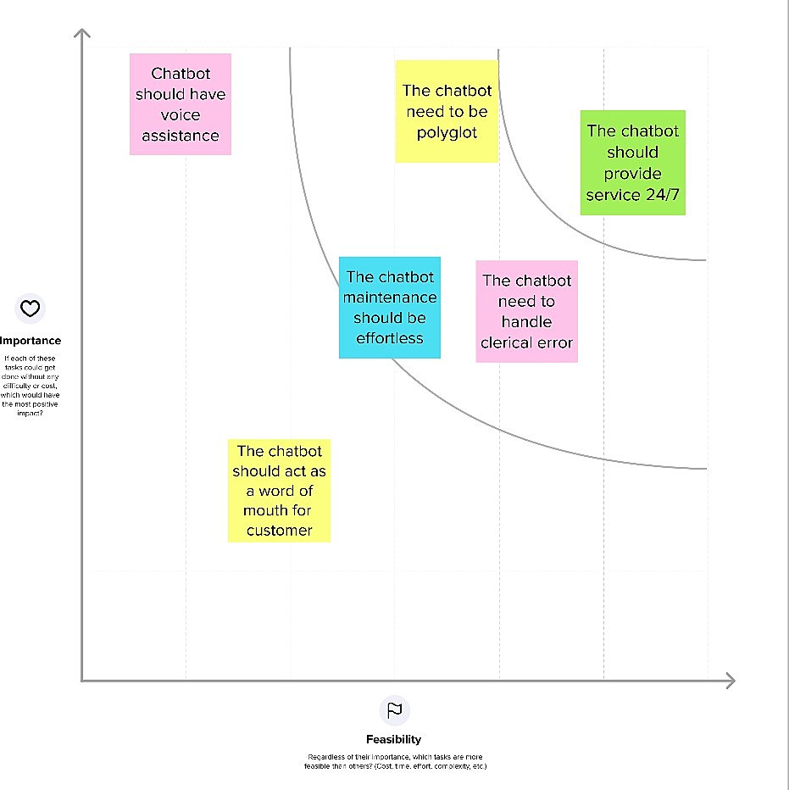

3.3 Proposed Solution

|  |  |  |
| --- | --- | --- |
| **S. No.** | **Parameter** | **Description** |
| 1. | Problem Statement  (Problem to be solved) | Banks are unable to satisfactorily respond to customer questions about their products or services, which lowers customer satisfaction. For simple questions, customers must routinely visit banks. |
| 2. | Idea / Solution description | An intelligent system must be implemented to help clients navigate all of the financial services the bank offers in order to offer people the best possible option. |
| 3. | Novelty / Uniqueness | AI-powered chatbots should be able to respond to any general banking questions including opening an account, loans, net banking, other services, etc. It quickly and effectively responds to client questions while being economical. |
| 4. | Social Impact / Customer Satisfaction | Chatbot will offer personalised and effective contact between the user and the bank in order to address the user satisfaction issues related to banking services. It is intended to serve as the all-encompassing virtual assistant that enables users to ask banking-related queries without going to the bank or calling customer care centres and to offer pertinent recommendations. |
| 5. | Business Model (Revenue Model) | For banks, using a chatbot to answer client questions will be a cost-effective solution. It does away with the |
|  |  | requirement for a sizable customer service team and even lessens the  workload of bank employees, whose time may be better spent elsewhere. |
| 6. | Scalability of the Solution | AI chatbots are available around-the-clock to answer all consumer questions and walk them through the entire banking procedure. It provides the voice assistance feature and keeps customer conversations private. It can be adjusted to the bank's specifications to include responses to inquiries about any new feature or  service the bank introduces. |

3.4 Problem Solution fit

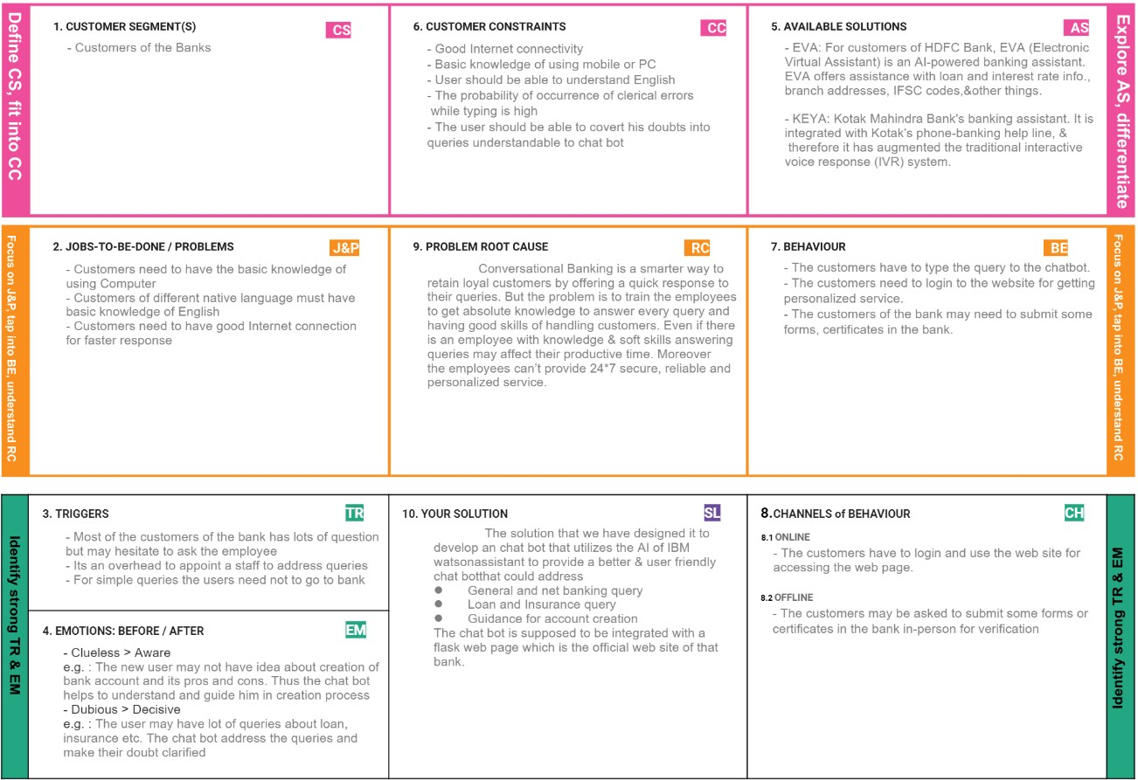

# 4.REQUIREMENT ANALYSIS

4.1 Functional requirement

Following are the functional requirements of the proposed solution.

|  |  |  |
| --- | --- | --- |
| **FR No.** | **Functional Requirement**  **(Epic)** | **Sub Requirement (Story / Sub-Task)** |
| FR-1 | Savings Account Creation | Questions about Kids Savings Accounts, Regular  Savings Accounts, and Zero Balance Savings  Accounts should be answered by the chatbot. |
| FR-2 | Current Account Creation | Queries about Partnership and Proprietorship accounts  should be able to be resolved by the chatbot. |
| FR-3 | Loan | The chatbot should be able to answer questions about student loans, house loans, gold loans, top-up loans, and car loans. |
| FR-4 | General Query | The chatbot should be able to respond to questions about the hours when banks are open, the currency conversion policy, storage lockers, a branch locator, a  list of available branches, CIBIL, etc. |
| FR-5 | Net Banking | What is net-banking? features of net banking, signing up for net banking, and issues with net banking should all be answered by the chatbot. |

4.2 Non-Functional requirements

Following are the non-functional requirements of the proposed solution.

|  |  |  |
| --- | --- | --- |
| **NFR no.** | **Non-Functional Requirement** | **Description** |
| NFR-1 | Usability | To improve customer experience, financial companies are using chatbots to automate the majority of their duties, including addressing client complaints, responding to inquiries, providing investment advice, etc., They can help organizations cut customer service expenses by up to 30%. |
| NFR-2 | Security | The most important part of banking is the security and privacy of customer data. We must make sure that only your bank may access the information collected from customers. Additionally, we need to incorporate a centralized authentication method with our chatbot solution. |
|  |  | The truth is that money is a delicate subject. |
| NFR-3 | Reliability | Because of this, the bot must represent two crucial qualities: security and dependability. Inaccurate transactions or errors in message interpretation can result in more serious problems, such as losing the customer. |
| NFR-4 | Performance | The chatbot's speed should be quicker than the time it would take a human to write the response. The chatbot should be coupled with a knowledge-based database and configured to swiftly retrieve information. |
| NFR-5 | Availability | Chatbots should be available 24/7 and not get tired. Any time of the day or night, they should be on call and prepared to respond to queries from late-night  visitors or just those in other time zones. |
| NFR-6 | Scalability | The chatbot should be designed scalable so that it can accommodate many users and other modules at once. The chatbot should also be designed to function in the majority of server setups. In light of this, a chatbot should be able to operate in any server environment. |

# 5.PROJECT DESIGN

5.1 Data Flow Diagrams

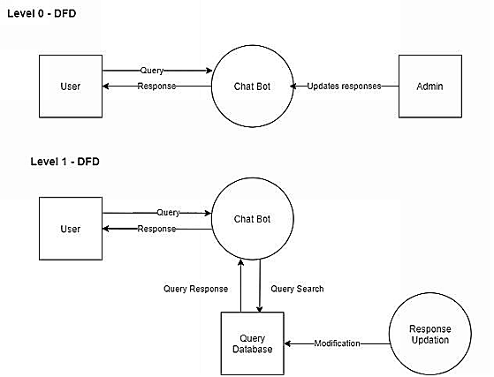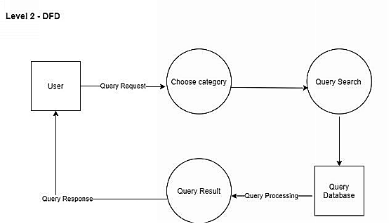

5.2 Solution & Technical Architecture

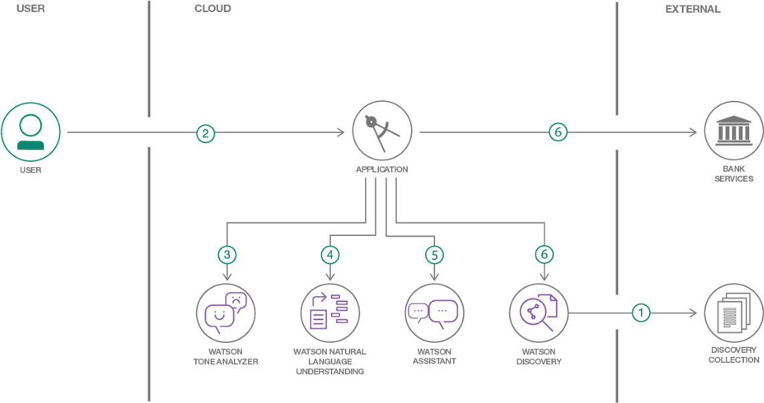

5.3 User Stories

|  |  |  |  |  |  |  |
| --- | --- | --- | --- | --- | --- | --- |
| **User type** | **Functional**  **Requireme**  **nt**  **(Epic)** | **User**  **Story**  **Numb er** | **User Story / Task** | **Acceptance criteria** | **Priority** | **Relea se** |
| Custom er  (Mobile or Web user) | Savings  Account Action | USN-1 | As a user, he/she can get the details of required documents for  Regular Savings  Account. | I can clear my queries regarding Regular Savings Account creation. | High | Sprint1 |
|  |  | USN-2 | As a user, I can check the details for creating  Kids Savings Account. | I can clear my queries regarding Kids  Savings  Account creation. | High | Sprint1 |
|  |  | USN-3 | As a user, I can check the details for creating  Zero Balance Savings  Account. | I can clear my queries regarding Zero Balance Savings  Account creation. | Low | Sprint1 |
|  | Current  Account Action | USN-4 | As a user, he/she can get the details of required documents for creating Partnership  Account. | I can clear my queries regarding Partnership  Account creation. | Medi um | Sprint2 |
|  |  | USN-5 | As a user, I can check | I can clear my queries | High | Sprint- |
|  |  |  | the details for creating  Proprietorship  Account. | regarding Proprietorship  Account creation. |  | 2 |
|  | Loan Action | USN-6 | As a user, he/she can get the details of required documents for availing student loan from the bank. | I can clear my queries regarding Student loan approval. | High | Sprint2 |
|  |  | USN-7 | As a user, I can check the details for availing gold loan, top-up loan, house loan, vehicle loan from the bank. | I can clear my queries regarding gold loan, top-  up loan, house loan, vehicle loan approval. | High | Sprint2 |
|  | General  Query  Action | USN-8 | As a user, he/she can question the bot about bank working hours, currency conversion policy, storage facility available in the bank. | I can clear my queries regarding bank working hours, currency conversion policy, storage facility available in the bank. | High | Sprint3 |
|  |  | USN-9 | As a user, I can query the bot about CIBIL score, list of available branches, nearest branch. | I can clear my queries regarding CIBIL score, list of available ranches, nearest branch. | Medi um | Sprint3 |
|  | Net  Banking Action | USN10 | As a user, he/she can question the bot about the significance and advantages of net banking. | I can clear my queries regarding features of net banking. | Low | Sprint3 |
|  |  | USN11 | As a user, I can get the details about steps involved in signing up for net banking, issues related to net banking. | I can clear my queries regarding issues in net banking. | Medi um | Sprint3 |
| Admin | Modifying  Action Skills | USN12 | As an admin, I can modify the responses ofthe bot. | I can modify the chat bot responses. | High | Sprint1 |
|  | Creating Action Skills | USN13 | As an admin, I can create new action skills and link it to existing ones. | I can add new action  skills. | High | Sprint1 |

# 6.PROJECT PLANNING & SCHEDULING

6.1 Sprint Planning & Estimation

|  |  |  |
| --- | --- | --- |
| **Title** | **Description** | **Date** |
| Literature Survey and Information Gathering | Gathering information by referring the technical papers, research publications etc. | 3 September 2022 |
| Prepare Empathy Map | To capture user’s pain and gains and prepare a list of Problem Statement | 10 September 2022 |
| Ideation | Prioritize a top 3 ideas based on feasibility and importance | 17 September 2022 |
| Proposed Solution | Solution include novelty, feasibility, business model, social impact and scalability of solution | 24 September 2022 |
| Problem Solution Fit | Prepare Solution fit document | 1 October 2022 |
| Solution Architecture | Prepare Solution Architecture document | 1 October 2022 |
| Customer Journey | To understand user’s interactions and experiences with application | 8 October 2022 |
| Functional Requirement | Prepare functional Requirement | 12 October 2022 |
| Data flow Diagrams | Prepare Data flow diagram | 12 October 2022 |
| Technology Architecture | Prepare Technology Architecture diagram | 12 October 2022 |
| Milestone & sprint delivery plan | Lists the activities what we done &further plans | 22 October 2022 |
| Project Development-  Delivery of sprint 1,2,3 & 4 | Develop and submit the developed code by testing it | 24 October 2022 –  19 November 2022 |

6.2 Sprint Delivery Schedule

|  |  |  |  |  |  |  |
| --- | --- | --- | --- | --- | --- | --- |
| **Sprint** | **Functional**  **Requirement (Epic)** | **User**  **Story**  **Number** | **User Story / Task** | **Story Points** | **Priority** | **Team Members** |
| Sprint1 | IBM Watson  Assistant Creation | USN-1 | As a user, I can register for IBM skills build and create a Watson Assistant Service. | 12 | High | Jilin Antony,  Rose Mary Santhosh,  R P Santhosh,  R Vijayalakshmi |
| Sprint1 | Action Skills Creation | USN-2 | As a user, I can add new action skills to resolve customer queries. | 4 | High | Jilin Antony,  Rose Mary Santhosh,  R P Santhosh,  R Vijayalakshmi |
| Sprint1 | Savings  Account Action | USN-3 | As a user, I can get the details of required documents for Regular Savings Account, Kids  Savings Account, and  Zero-Balance Savings  Account. | 4 | Low | Jilin Antony,  Rose Mary Santhosh,  R P Santhosh,  R Vijayalakshmi |
| Sprint2 | Current  Account Action | USN-4 | As a user, I can get the details of required documents for creating  Partnership,  Proprietorship Account. | 10 | Medi um | Jilin Antony,  Rose Mary Santhosh,  R P Santhosh,  R Vijayalakshmi |
| Sprint2 | Loan Action | USN-5 | As a user, I can get the details of required documents for availing gold loan, top-up loan, housing loan, vehicle loan from the bank. | 10 | High | Jilin Antony,  Rose Mary Santhosh,  R P Santhosh,  R Vijayalakshmi |
| Sprint3 | General  Query Action | USN-6 | As a user, I can get resolved for the queries like CIBIL score, storage facilities available in the bank, currency conversion policy, list of branches, nearest branch available. | 10 | High | Jilin Antony,  Rose Mary Santhosh,  R P Santhosh,  R Vijayalakshmi |
| Sprint3 | Net Banking Action | USN-7 | As a user, I can get resolved for the queries like features of net banking, issues regarding net banking, etc., | 10 | Medi um | Jilin Antony,  Rose Mary Santhosh,  R P Santhosh,  R Vijayalakshmi |
| Sprint4 | Building  Python code | USN-8 | As an admin, I make use of the Flask framework | 12 | High | Jilin Antony,  Rose Mary Santhosh,  R P Santhosh,  R Vijayalakshmi |
|  | (using Flask frame work) |  | to link a html web page. |  |  |  |
| Sprint4 | Building  HTML code | USN-9 | As an admin, I make use of html to create the web page as a front-end for the application. | 6 | High | Jilin Antony,  Rose Mary Santhosh,  R P Santhosh,  R Vijayalakshmi |
| Sprint4 | Executing the application | USN-10 | As an admin, I can integrate the chat bot with our web page. As a user, I can interact with the chatbot in the web page. | 2 | Medi um | Jilin Antony,  Rose Mary Santhosh,  R P Santhosh,  R Vijayalakshmi |

6.3 Project Tracker

|  |  |  |  |  |  |  |
| --- | --- | --- | --- | --- | --- | --- |
| **Sprint** | **Total**  **Story**  **Points** | **Duration** | **Sprint Start Date** | **Sprint End Date**  **(Planned)** | **Story**  **Points**  **Completed**  **(as on**  **Planned**  **End Date)** | **Sprint Release Date (Actual)** |
| Sprint-1 | 20 | 6 Days | 24 Oct 2022 | 29 Oct 2022 | 20 | 26 Oct 2022 |
| Sprint-2 | 20 | 6 Days | 31 Oct 2022 | 05 Nov 2022 | 20 | 02 Nov 2022 |
| Sprint-3 | 20 | 6 Days | 7 Nov 2022 | 12 Nov 2022 | 20 | 09 Nov 2022 |
| Sprint-4 | 20 | 6 Days | 14 Nov 2022 | 19 Nov 2022 | 20 | 16 Nov 2022 |

6.4 Burndown Chart

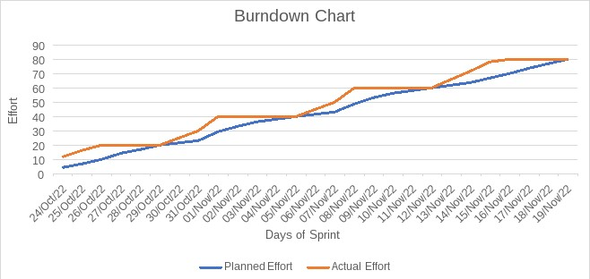

6.5 Reports from JIRA

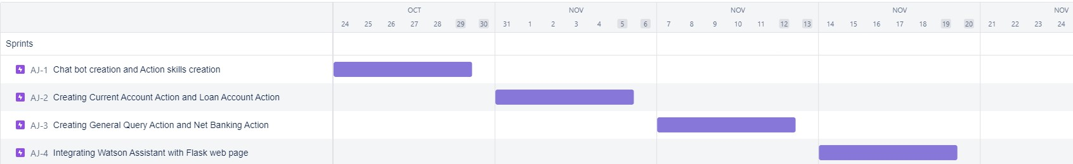

# 7.CODING & SOLUTIONING

7.1 Creating IBM Watson Assistant Service

In this activity, we are creating the necessary IBM Watson Service.

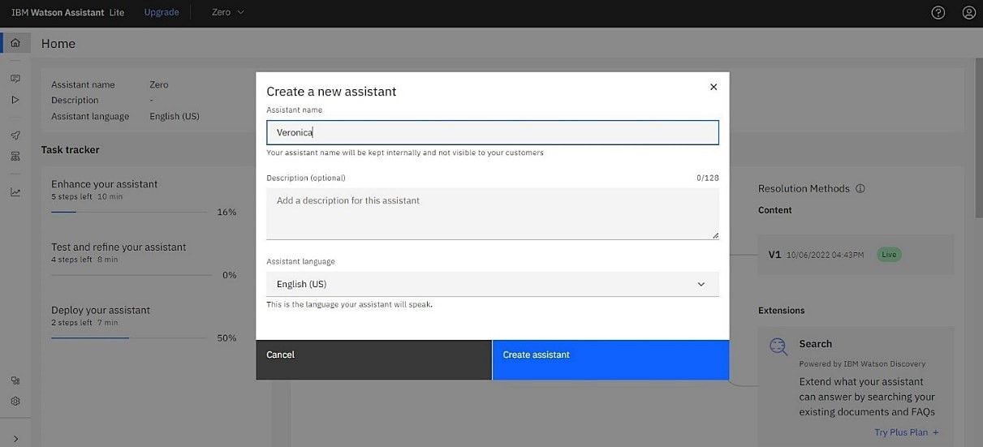

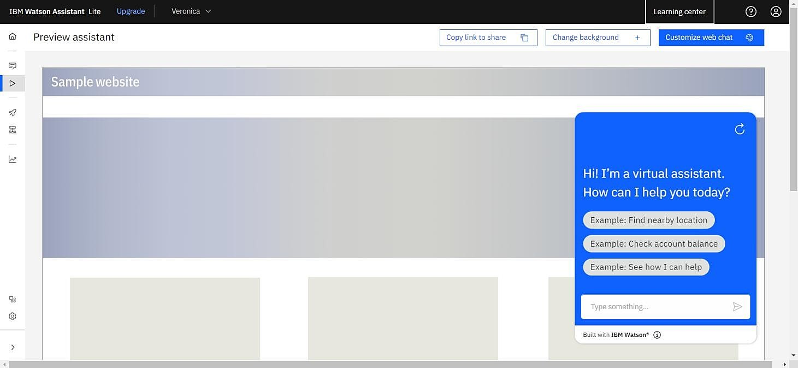

7.2 Creating Action skills

Skills are nothing but actions and steps. Steps are the subset of actions where conversations are built and the assistant is integrated with these skills.

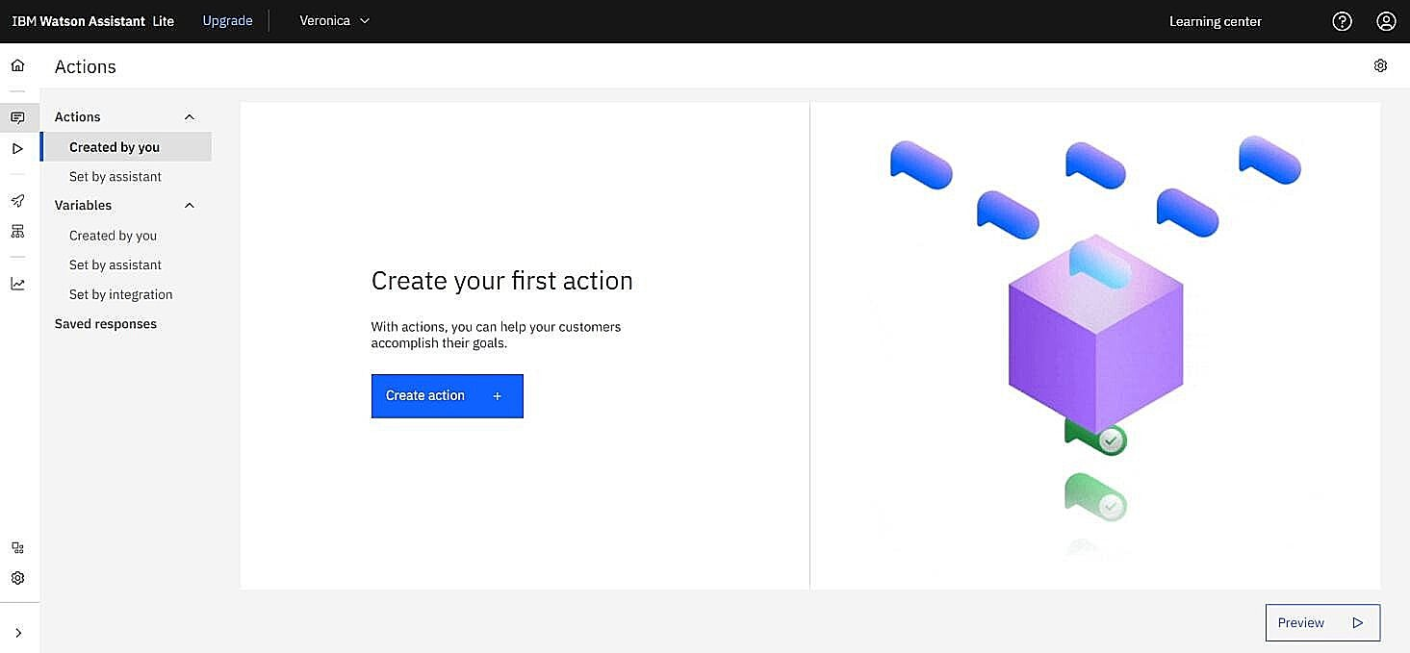

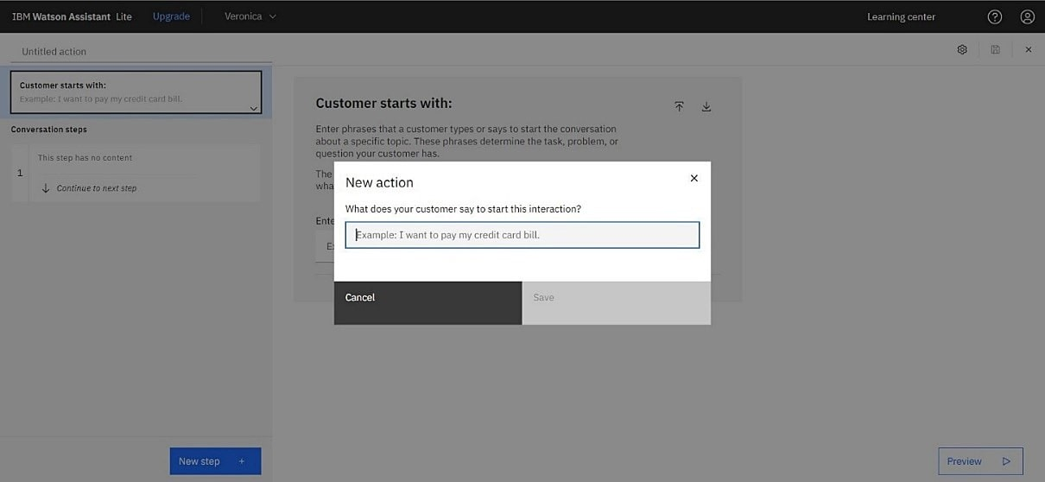

7.2.1 Creating savings action

In this step, we are adding steps in Savings Action to handle customer queries regarding Regular Savings Account, Kids Savings Account and Zero - Balance Account creation.

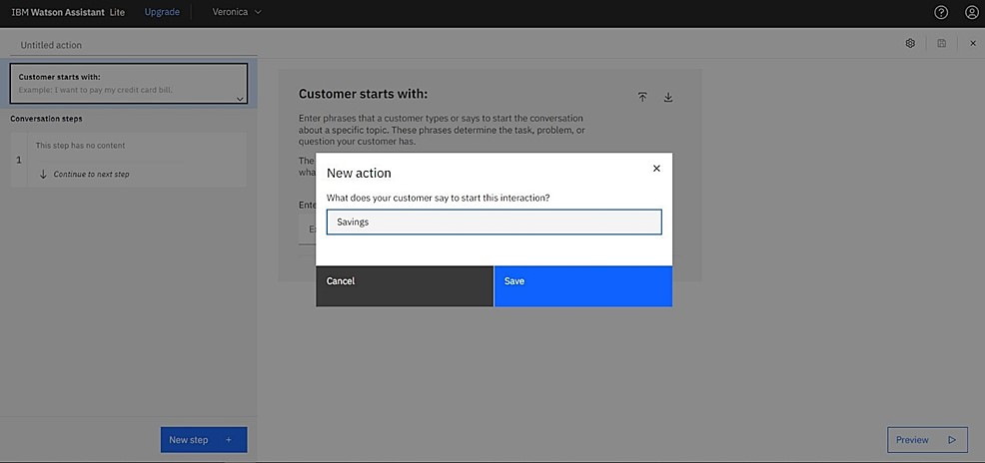

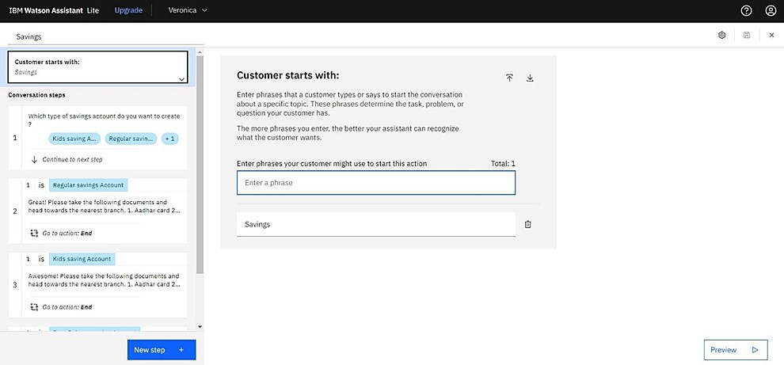

7.2.2 Creating Loan action

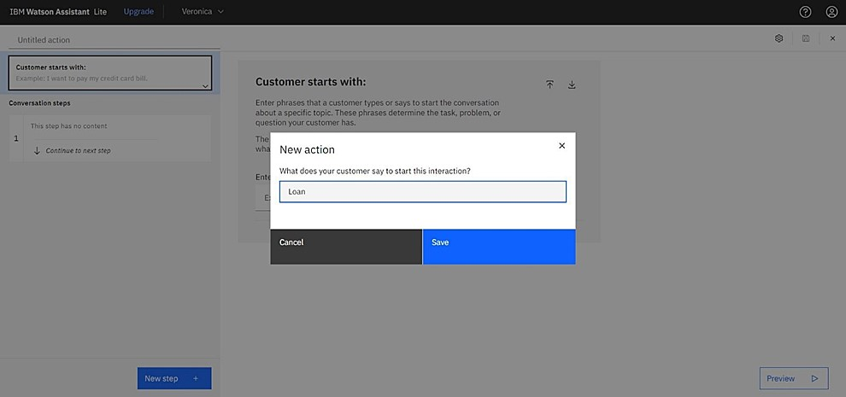

Adding steps in loan action to handle customer queries regarding Housing loan, gold loan, Top-up loan, Student loan, and Vehicle loan.

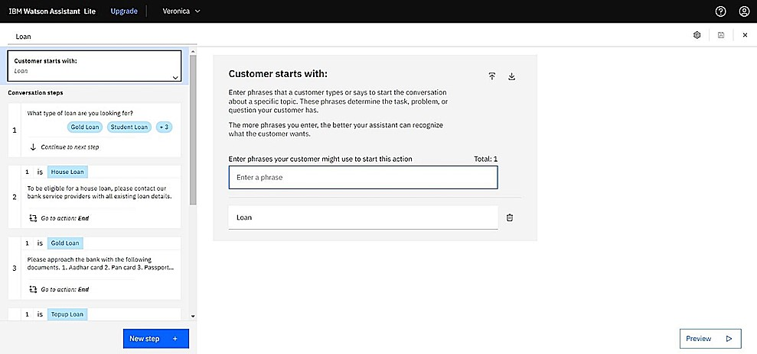

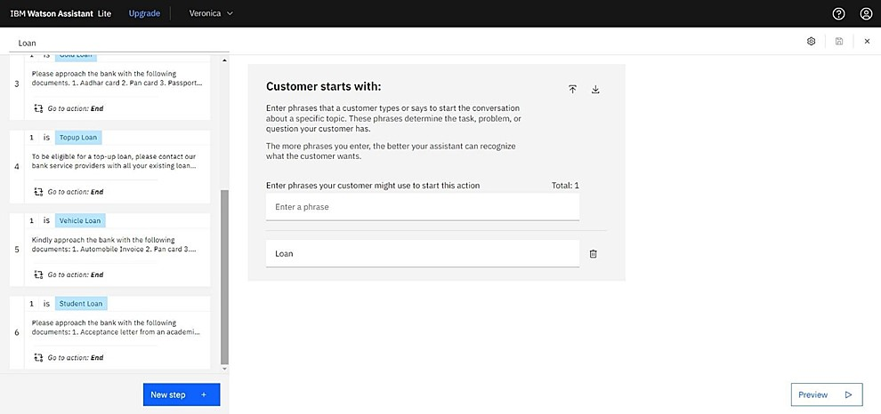

7.2.3 Creating current account action

Create a new action skill Current, for the current account action.

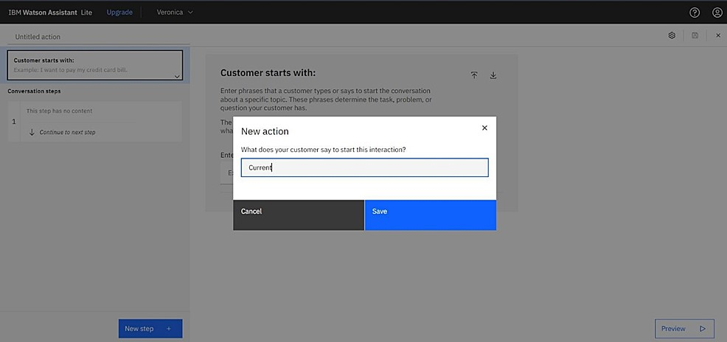

Adding steps in Current action to handle customer queries regarding Partnership and Proprietorship account creation.

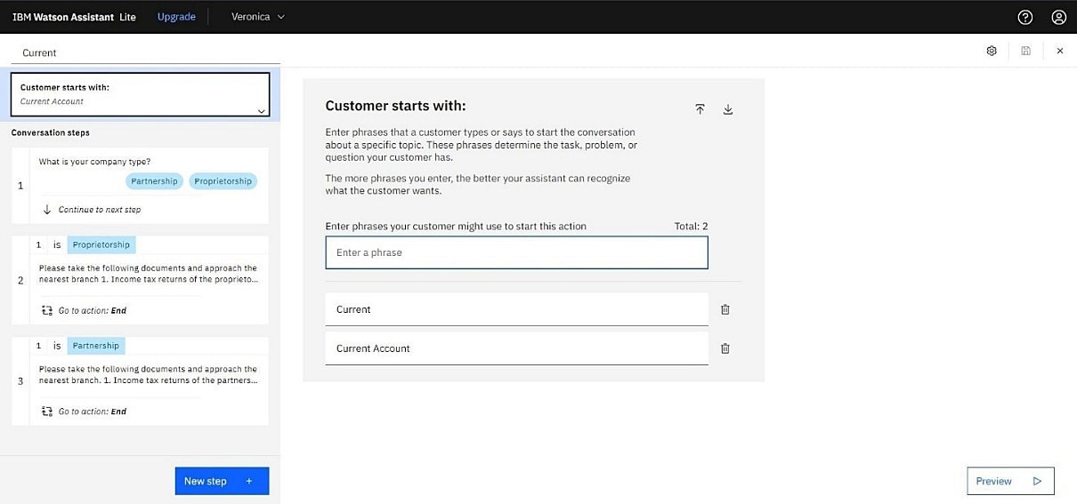

7.2.4 Creating general query action

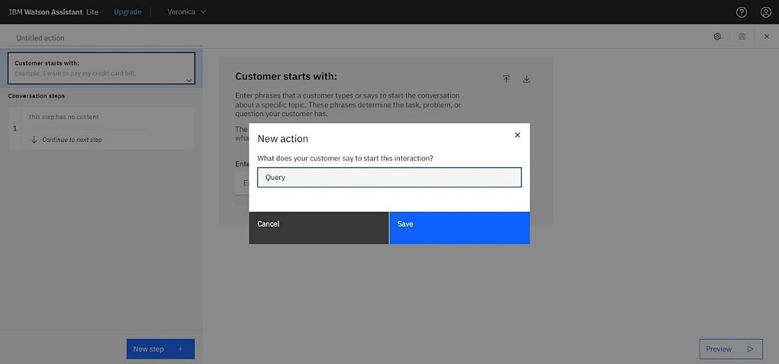

Adding steps in Query action to handle queries regarding Bank working hours, Currency conversion policy, Storage locker facility, CIBIL score, list of all branches, nearest available branch, etc.,

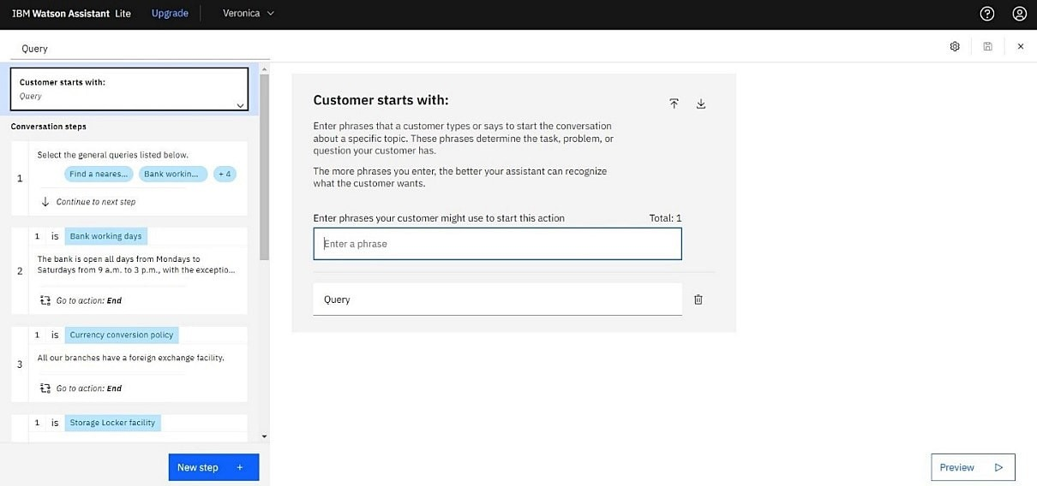

7.2.5 Creating net banking action

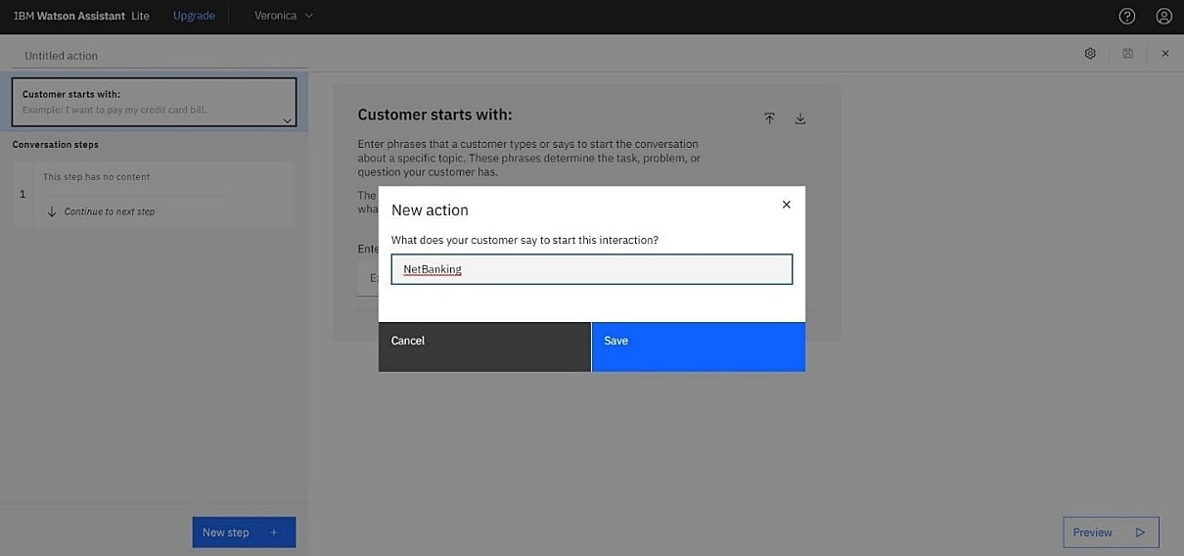

Adding steps in Net Banking Action skill to handle queries of customers regarding significance and issues of net banking.

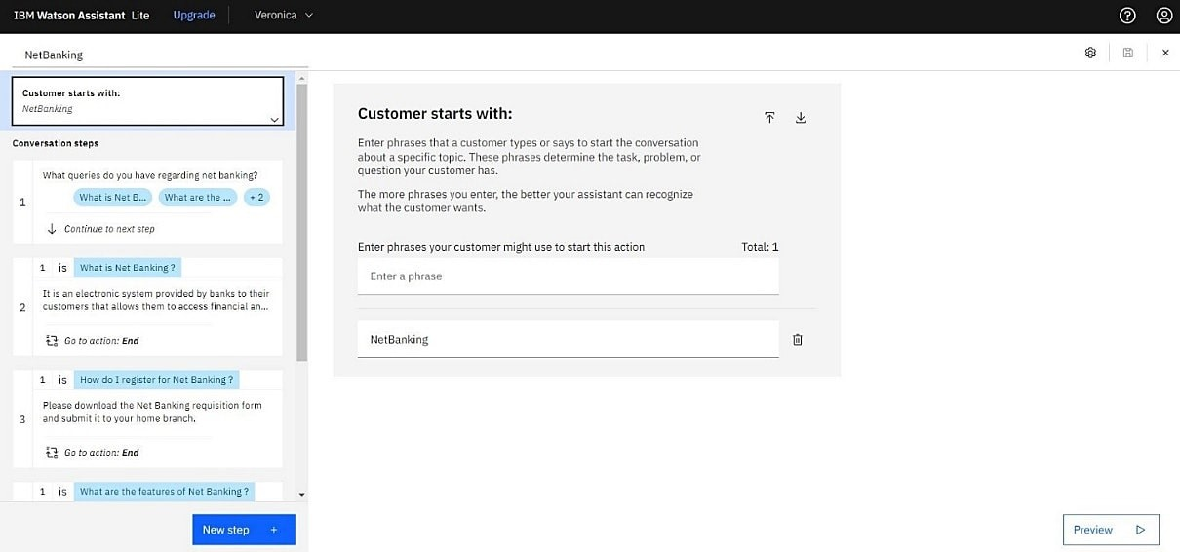

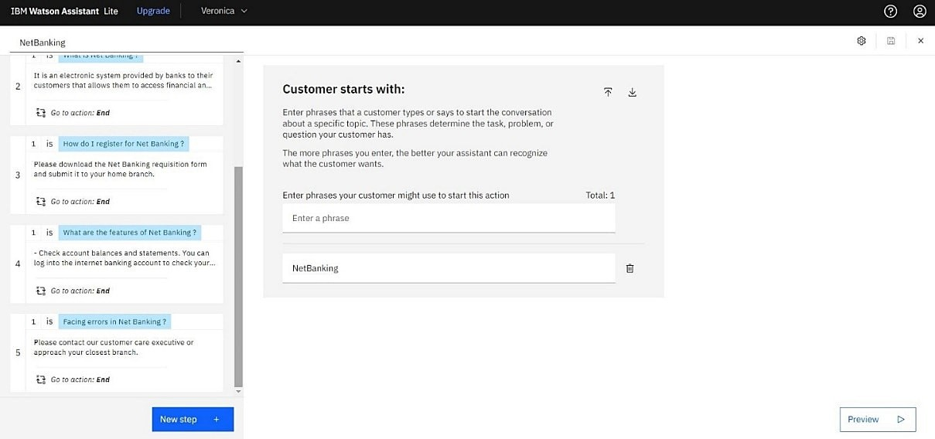

7.2.6 Additional action skills

In addition to this greeting, end greeting, index and end actions are also created.

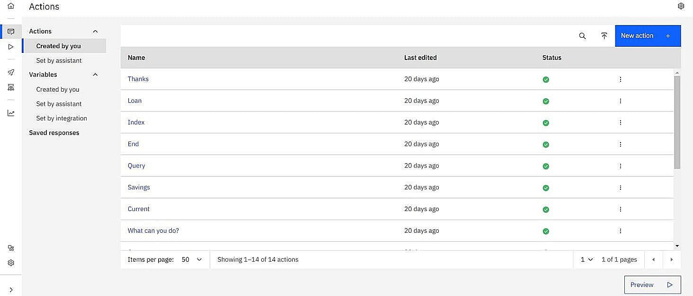

7.3 Creation of Watson assistant & Integration with web site using Flask

Let us build our flask application which will be running in our local browser as an user interface. In the flask application, users will interact with the chat bot, and based on the user queries they will get the chatbot responses.

7.3.1 Building Python Code

The first step is usually importing the libraries that will be needed in the program.



Importing the flask module into the project is mandatory. An object of the Flask class is our WSGI application. Flask constructor takes the name of the current module

(___name__).

7.3.2 Creation and loading of Flask application



7.3.3 Building webpage using html

We have used HTML to create the front-end part of the web page.

Here, we have created “index.html” displays the home page which gets integrated with Watson Assistant.

Auto-generated source code which contains the Integration ID of IBM Watson Assistants is copied and pasted inside the body tag.

<script>

window.watsonAssistantChatOptions = {

integrationID: "918fa72b-fd0c-4ae1-9cd1-f4806c3b969d", // The ID of this integration.

region: "us-south", // The region your integration is hosted in.

serviceInstanceID: "376d815a-56b4-4f07-8c87-301053bbd5cd", // The ID of your service instance.

onLoad: function(instance) { instance.render(); }

};

setTimeout(function(){

const t=document.createElement('script');

t.src="https://web-chat.global.assistant.watson.appdomain.cloud/versions/" +

(window.watsonAssistantChatOptions.clientVersion || 'latest') +

"/WatsonAssistantChatEntry.js";

document.head.appendChild(t);

});

</script>

7.3.4 Routing to web site

Here, the declared constructor is used to route to the HTML page create dearlier. The ‘/’ route is bound with the bot function. Hence, when the home page of a web server is opened in the browser, the HTML page will be rendered.

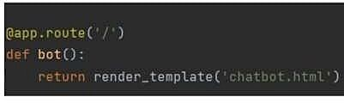

Main Function:

This is used to run the application in local host.



7.3.5 Run the application

The application can be run using the following guidelines

1. Open Jupyter notebook (anaconda3)
2. Navigate to the folder where app.ipynb resides.Run the python code
3. Open a browser and type this URL http://127.0.0.1:5000/ *4.* It launches the application integrated with IBM Watson Assistant.

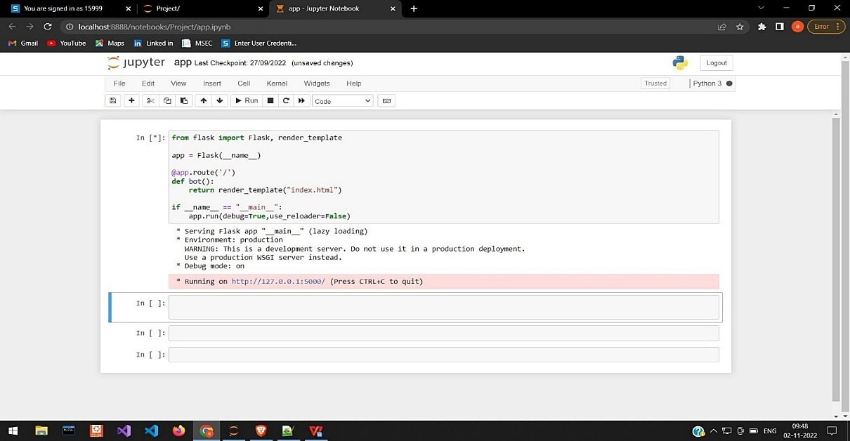

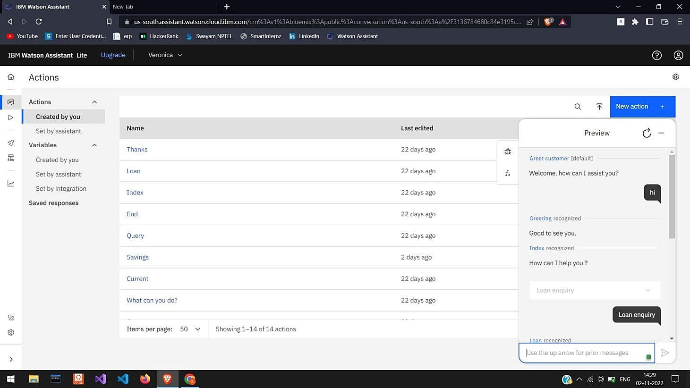

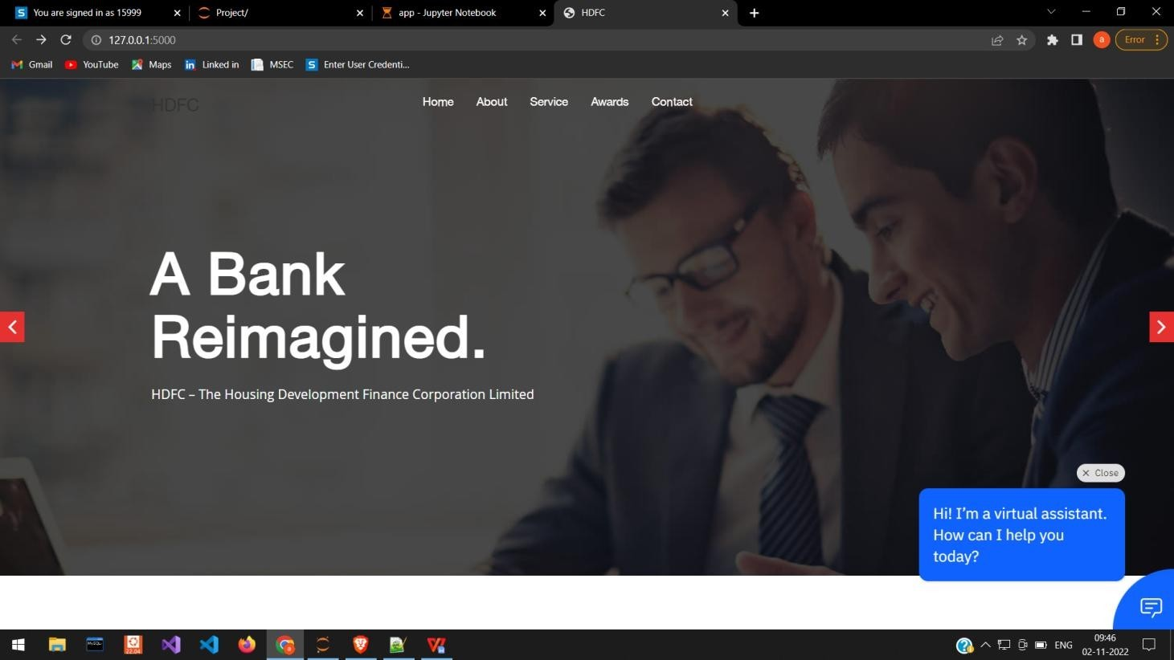

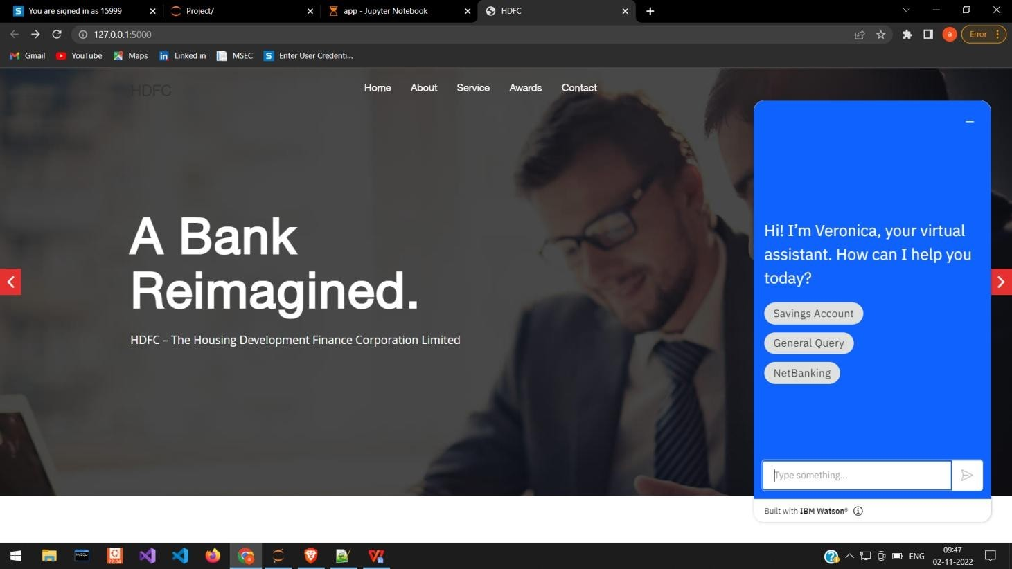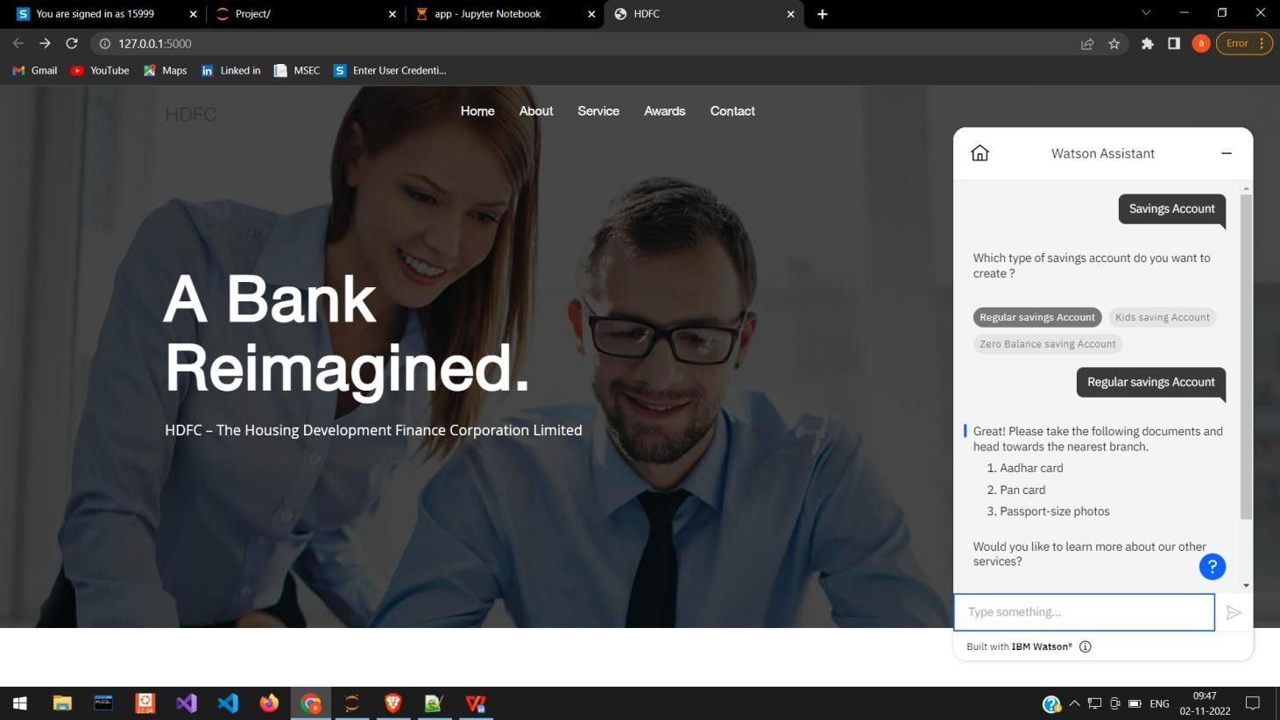

# 8.TESTING

8.1 Test Cases Scenarios

|  |  |
| --- | --- |
| **Test Scenarios no.** | **Test Scenarios** |
| **TS_001** | Verify user is able to see the chatbot icon when website is launched |
| **TS_002** | Verify the UI elements in chatbot icon popup |
| **TS_003** | Verify user is able to see the gree ng from chatbot "Hi! I'm a Banking Bot. How can I help you today? Savings account, General query, Net banking |
| **TS_004** | Verify user is able to type query in text field. |
| **TS_005** | Verify user is able to get the response from chatbot |
| **TS_006** | Verify user whether get the response if the user enters the query with clerical error |

8.2 User Acceptance Testing

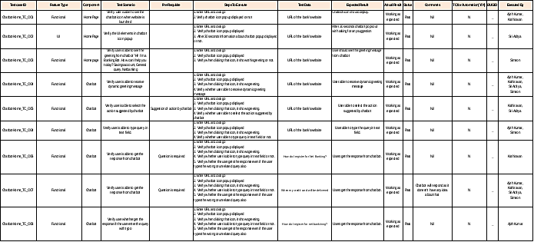

8.3 UAT Report

8.3.1 **Defect Analysis**

This report shows the number of resolved or closed bugs at each severity level, and how they were resolved

|  |  |  |  |  |  |
| --- | --- | --- | --- | --- | --- |
| **Resolution** | **Severity 1** | **Severity 2** | **Severity 3** | **Severity 4** | **Subtotal** |
| By Design | 5 | 3 | 1 | 2 | 11 |
| Duplicate | 1 | 0 | 3 | 1 | 5 |
| External | 3 | 2 | 1 | 1 | 7 |
| Fixed | 10 | 1 | 3 | 15 | 29 |
| Not Reproduced | 0 | 0 | 0 | 1 | 1 |
| Skipped | 0 | 1 | 2 | 1 | 4 |
| Won't Fix | 0 | 5 | 2 | 1 | 8 |
| Totals | 19 | 12 | 12 | 22 | 65 |

8.3.2 **Test Case Analysis**

This report shows the number of test cases that have passed, failed, and untested

|  |  |  |  |  |
| --- | --- | --- | --- | --- |
| **Section** | **Total Cases** | **Not Tested** | **Fail** | **Pass** |
| Bank’s website | 5 | 0 | 0 | 5 |
| Complex query handling | 3 | 0 | 0 | 3 |
| Clerical error handling | 7 | 0 | 0 | 7 |
| Response for unknown ques on | 5 | 0 | 0 | 5 |
| Dynamic gree ng | 5 | 0 | 0 | 5 |
| Next ac on sugges on | 13 | 0 | 0 | 13 |
| Chatbot query handling | 47 | 0 | 0 | 47 |

# 9.RESULTS

9.1 Performance Metrics

For the Ai-based discourse for Banking Industry project we do not build any explicit model for enabling conversation between the user and a query handling chatbot. We utilized the IBM service (Watson Assistant) to provide such a service. So there is no performance evaluation using matrices like accuracy, confidence score etc.,

# ADVANTAGES & DISADVANTAGES

**Advantages**

**Fast-pace communication:**

In the case of speech chatbots, this is particularly accurate. Some individuals believe that phone contacts with real supervisors are unnecessarily slow and frustrating. Due to their frequent encounters with irate customers, customer support representatives may also find live communication difficult. And no matter how stupid, irate, or irritating the caller is, they have to do it every day and follow protocol. A well-designed chatbot will always be courteous. They reply immediately and don't forget things, therefore their behaviour is independent of their emotions.

**Round-the-clock support:**

Because chatbots offer round-the-clock customer service, both current and future clients can try to resolve their financial issues after work and on the weekends. Additionally, this ultimately improves consumer satisfaction.

**Enhanced productivity of bank personnel:**

Not all client issues call for assistance from personnel. Minor problems may be successfully resolved by artificial intelligence, leaving just the most urgent and difficult cases for the "human method." Therefore, the usage of chatbots frees up some of the time of the staff and increases the effectiveness of customer service. Additionally, such application enables businesses to concentrate the attention and efforts of knowledgeable specialists on crucial issues that cannot be resolved by AI.

**Convenient mode of communication:**

Chatbots may integrate a variety of features that would make them practical for users of all ages. Chatbots may meet this need because, psychologically, younger generations prefer instant messaging to voice communication. However, elderly people might have trouble typing their requests, so a voice bot might be more appropriate for them.

**Provide a personalized experience:**

Even before they begin a discussion, chatbots have access to all of the data on the current customer. Based on the phone number, login/password, authorization token, or other safe and trustworthy forms of identification, they automatically identify and verify the customer. They can then address a customer by name, speak to them in their native tongue, recommend special deals and promotions, etc.

**Disadvantages**

**Lack of human emotion and intelligence:**

Chatbot still fall behind on human emotions in specific situations and can seem robotic while answering certain complex questions. Fortunately, this gap is decreasing by the day with new and advancement programs.

**Unsuitable for some customers:**

In case the customer is multilingual, or uses a region-specific language, the chatbot may or may not be able to carry out the conversation efficiently. This can be a problem in a country like India, where people speak multiple languages and often slip in regional references in their conversations.Some customers still like the age-old format of calling the bank and speaking to a customer service representative to solve their issues, no matter how big or small it may be.

**Requires technical expertise:**

Although chatbot is designed to reduce human workload, banking sector organizations still need to employ human resources with technical knowhow to handle and manage this chatbot.

**Limited to direct questions:**

Chatbot is efficient in answering direct questions. They are also equipped to answer questions one by one. If the customer asks multiple questions in a single breath, the answers are likely to be inaccurate and incomplete.

**The fear of taking over humans:**

Just like any other form of technology, the fear of technology taking over humans always lingers in the air when using a chatbot. Many people are still uncomfortable using them and prefer to go the old-fashioned route.

# CONCLUSION

In every sector where top-notch customer assistance is required, chatbots and other AI helpers are quite helpful. The financial or banking sector is one such industry that is swiftly incorporating new technology into its process. Money and reputation are everything in banking, and AI chatbots have many advantages for both.

# FUTURE SCOPE

The percentage of banks utilizing AI tools, and chatbots in particular, is steadily increasing. Another factor is the fast-expanding tendency of using smartphones and other smart devices. The immediate future of artificial intelligence assistants in the banking sector is determined by these two driving forces.

Chatbots are becoming more and more common in bank mobile apps. This makes it simple for them to stay in touch with their customers while also minimizing the need for human staff. According to projections made by Juniper Research, chatbot engagements would save banks 862 million hours in 2023, which equates to a global cost reduction of $7.3 billion.

In the coming years, chatbot quality will undoubtedly increase. They will learn to better understand demands as they grow more "human," Chatbots will become more adept at predicting human behavior as a result, and they will use this knowledge to continue to improve.

Voice assistants will undoubtedly become more prevalent in the upcoming years across all industries, including banking. For instance, they will significantly speed up client communications. Additionally, the offered functionality will expand, leading to more use cases for chatbots.

Future use of chatbots in the banking sector will continue to raise security issues. The demand for secure and trustworthy AI solutions will become a key factor in the growth of digital technology. The explanation is straightforward: people will only consent to give their credit card information and private information to the most reputable and secure software solutions, including chatbots.

# APPENDIX

**Source Code**

**App.py**

from flask import Flask, render_template

app = Flask(__name__)

@app.route('/') def bot():

return render_template("index.html")

if __name__ == "__main__":

app.run(debug=True,use_reloader=False)

**Index.html**

<!DOCTYPE html>

<html lang="en">

<head>

<meta charset="utf-8">

<meta name="viewport" content="width=device-width, initial-scale=1.0">

<meta name="description" content="">

<meta name="author" content="">

<title>HDFC</title>

<!--Bootstrap-->

<link rel="stylesheet" type="text/css" href="static/css/bootstrap.css" />

<!--Stylesheets-->

<link rel="stylesheet" type="text/css" href="static/css/style.css" />

<!--Responsive-->

<link rel="stylesheet" type="text/css" href="static/css/responsive.css" /> <!--Animation-->

<link rel="stylesheet" type="text/css" href="static/css/animate.css">

<!--Prettyphoto-->

<link rel="stylesheet" type="text/css" href="static/css/prettyPhoto.css" /> <!--Font-Awesome-->

<link rel="stylesheet" type="text/css" href="static/css/font-awesome.css" /> <!--Owl-Slider-->

<link rel="stylesheet" type="text/css" href="static/css/owl.carousel.css" />

<link rel="stylesheet" type="text/css" href="static/css/owl.theme.css" />

<link rel="stylesheet" type="text/css" href="static/css/owl.transitions.css" />

<!--[if lt IE 9]>

<script src="js/html5shiv.js"></script>s

<script src="js/respond.min.js"></script>

[endif]-->

</head>

<body data-spy="scroll" data-target=".navbar-default" data-offset="100"> <!--Preloader-->

<div id="preloader">

<div id="pre-status">

<div class="preload-placeholder"></div>

</div>

</div>

<!--Navigation-->

<header id="menu">

<div class="navbar navbar-default navbar-fixed-top">

<div class="container">

<div class="container-fluid">

<!-- Brand and toggle get grouped for better mobile display -->

<div class="navbar-header">

<button type="button" class="navbar-toggle collapsed" data-toggle="collapse" datatarget="#bs-example-navbar-collapse-1" aria-expanded="false">

<span class="sr-only">Toggle navigation</span>

<span class="icon-bar"></span>

<span class="icon-bar"></span>

<span class="icon-bar"></span>

</button>

<a class="navbar-brand" href="#menu">

<h3> HDFC </h3>

</a>

</div>

<!-- Collect the nav links, forms, and other content for toggling -->

<div class="collapse navbar-collapse" id="bs-example-navbar-collapse-1">

<ul class="nav navbar-nav">

<li class="active">

<a class="scroll" href="#menu">Home</a>

</li>

<li>

<a class="scroll" href="#about">About</a>

</li>

<li>

<a class="scroll" href="#service">Service</a>

</li>

<li>

<a class="scroll" href="#features">Awards</a>

</li>

<!-- <li><a class="scroll" href="#portfolio">Portfolio</a></li><li><a class="scroll" href="#pricing">Pricing</a></li> -->

<!-- <li><a class="scroll" href="#team">Team</a></li> -->

<!-- <li><a class="scroll" href="#blog">Blog</a></li> -->

<li>

<a class="scroll" href="#contact">Contact</a>

</li>

</ul> </div>

<!-- /.navbar-collapse -->

</div>

<!-- /.container-fluid -->

</div>

</div>

</header>

<!--Slider-Start-->

<section id="slider">

<div id="home-carousel" class="carousel slide" data-ride="carousel">

<div class="carousel-inner">

<div class="item active" style="background-image:url(static/images/Slider/01.jpg)">

<div class="carousel-caption container">

<div class="row">

<div class="col-md-7 col-sm-12 col-xs-12">

<!-- <h1>We Are Cosmix</h1> -->

<h2>A Bank Reimagined.</h2>

<p>HDFC – The Housing Development Finance Corporation Limited </p>

</div>

</div>

</div> </div>

<div class="item" style="background-image:url(static/images/Slider/02.jpg)">

<div class="carousel-caption container">

<div class="row">

<div class="col-md-7 col-sm-12 col-xs-12">

<!--<h1>We Are Cosmix</h1>-->

<h2>A Bank Reimagined.</h2>

<p>HDFC – The Housing Development Finance Corporation Limited </p>

</div>

</div>

</div> </div>

<div class="item" style="background-image:url(static/images/Slider/03.jpg)">

<div class="carousel-caption container">

<div class="row">

<div class="col-md-7 col-sm-12 col-xs-12">

<h2>A Bank Reimagined.</h2>

<p>HDFC – The Housing Development Finance Corporation Limited </p>

</div>

</div>

</div>

</div>

<a class="home-carousel-left" href="#home-carousel" data-slide="prev">

<i class="fa fa-angle-left"></i>

</a>

<a class="home-carousel-right" href="#home-carousel" data-slide="next"> <i class="fa fa-angle-right"></i>

</a>

</div>

</div>

<!--/#home-carousel-->

</section>

<!--About-Section-Start-->

<section id="about">

<div class="container">

<div class="col-md-8 col-md-offset-2">

<div class="heading">

<h2>ABOUT <span>US</span>

</h2>

<div class="line"></div>

<p>

<span>

<strong>(HDFC) </strong>

</span>a name that has been associated with the Indian housing sector for the last four decades.

</p>

</div>

</div>

<div class="row">

<div class="col-md-12 ab-sec">

<div class="col-md-6">

<h3 class="wow fadeInDown" data-wow-duration="1000ms" data-wow-delay="300ms"> <span>W</span>ho we Are ?

</h3>

<p>

<span>

<strong></strong>

</span>Our mission is to be a world class Indian bank. We have a two-fold objective: first, to be the preferred provider of banking services for target retail and wholesale customer segments. The second objective is to achieve healthy growth in profitability, consistent with the bank's risk appetite.

</p>

</div>

<div class="col-md-6 ab-sec-img wow fadeInUp" data-wow-duration="1000ms" data-wowdelay="300ms">

<img src="static/images/Aboutus/01.jpg" alt="">

</div>

</div>

</div>

</div>

</section>

<!--About-Sec-2-Start-->

<!--<div class="bg-sec"><div class="container"><div class="col-md-10 col-sm-10 col-xs8"><h3>Premium quality free onepage template</h3><p>Lorem ipsum dolor sit amet, consectetur adipisicing elit, sed do eiusmod</p></div><div class="col-md-2 col-sm-2 col-xs-

4"><a class="btn-down" href="#">Download</a></div></div></div> --> <!--Service-Section-Start-->

<section id="service">

<div class="container">

<div class="col-md-8 col-md-offset-2">

<div class="heading">

<h2>OUR SERVI <span>CES</span>

</h2>

<div class="line"></div>

<p>

<span>

<strong></strong>

</span>HDFC Bank provides a number of products and services including wholesale banking, retail banking, treasury, auto loans, two-wheeler loans, personal loans, loans against property, consumer durable loan, lifestyle loan and credit cards. Along with this various digital products are Payzapp and SmartBUY.

</p>

</div>

</div>

<div class="row">

<div class="features-sec">

<div class="col-md-4 col-sm-6 col-xs-6 wow fadeInUp" data-wow-duration="300ms" datawow-delay="0ms">

<div class="media service-box">

<div class="pull-left">

<!--<i class="fa fa-line-chart"></i> -->

</div>

<div class="media-body">

<h5 class="media-heading">Savings Account</h5>

<p>HDFC Bank offers 11 types of savings accounts to serve the financial needs of students, entrepreneurs, salaried employees, or senior citizens. From regular to premium savings account, one can manage the money efficiently.</p>

</div>

</div>

</div>

<!--/.col-md-4-->

<div class="col-md-4 col-sm-6 col-xs-6 wow fadeInUp" data-wow-duration="300ms" datawow-delay="100ms">

<div class="media service-box">

<div class="pull-left">

<!-- <i class="fa fa-cubes"></i> -->

</div>

<div class="media-body">

<h5 class="media-heading">Current Account</h5>

<p> HDFC Bank offers 18 types of current accounts to serve the needs of different businesses. Current accounts largely deal with liquid deposits does not limit the number of transactions in a day and easily allows for the withdrawal of funds.</p>

</div>

</div>

</div>

<!--/.col-md-4-->

<div class="col-md-4 col-sm-6 col-xs-6 wow fadeInUp" data-wow-duration="300ms" datawow-delay="200ms">

<div class="media service-box">

<div class="pull-left">

<!-- <i class="fa fa-pie-chart"></i> -->

</div>

<div class="media-body">

<h5 class="media-heading">Home Loan</h5>

<p> HDFC Bank offers 3 types of home loans for its customers at attractive interest rates. Customers can opt for automated repayment and the EMIs will be directly repaid from HDFC Bank Savings Account. </p>

</div>

</div>

</div>

<!--/.col-md-4-->

<div class="col-md-4 col-sm-6 col-xs-6 wow fadeInUp" data-wow-duration="300ms" datawow-delay="300ms">

<div class="media service-box">

<div class="pull-left">

<!-- <i class="fa fa-bar-chart"></i> -->

</div>

<div class="media-body">

<h5 class="media-heading">Personal Loan</h5>

<p> HDFC Bank offers a personal loan to its customers at attractive interest rates, low processing fees, & simplified documentation. Customers can also avail pre-approved loan in 10 seconds and others can get a loan in 4 hours.</p>

</div>

</div>

</div>

<!--/.col-md-4-->

<div class="col-md-4 col-sm-6 col-xs-6 wow fadeInUp" data-wow-duration="300ms" datawow-delay="400ms">

<div class="media service-box">

<div class="pull-left">

<!-- <i class="fa fa-language"></i>-->

</div>

<div class="media-body">

<h5 class="media-heading">Car Loan</h5>

<p>HDFC Bank helps to finance the dream of buying a new car for its customers with up to 100% funding. Customers can opt for 3 types of car loans as per their requirement with 7 year loan tenure, quick disbursal, and processing.</p>

</div>

</div>

</div>

<!--/.col-md-4-->

<div class="col-md-4 col-sm-6 col-xs-6 wow fadeInUp" data-wow-duration="300ms" datawow-delay="500ms">

<div class="media service-box">

<div class="pull-left">

<!-- <i class="fa fa-bullseye"></i> -->

</div>

<div class="media-body">

<h5 class="media-heading">Educational Loan</h5>

<p> HDFC Bank offers 3 types of education loan to its customers studying across leading institutions in India & overseas to fulfill their career goals & aspirations. Customers can also avail tax benefits u/s 80 (E) of Income Tax Act, 1961.</p>

</div>

</div>

</div>

<!--/.col-md-4-->

<!--/.col-md-4-->

<div class="col-md-4 col-sm-6 col-xs-6 wow fadeInUp" data-wow-duration="300ms" datawow-delay="500ms">

<div class="media service-box">

<div class="pull-left">

<!-- <i class="fa fa-bullseye"></i> -->

</div>

<div class="media-body">

<h5 class="media-heading"> Loan against Property</h5>

<p> HDFC Bank customers can pledge their property to meet the personal or business goals with 4 types of loan against property. Customers can get up to 65% of one’s property’s value, attractive interest rates, and hassle-free processing.</p>

</div>

</div>

</div>

<!--/.col-md-4-->

<!--/.col-md-4-->

<div class="col-md-4 col-sm-6 col-xs-6 wow fadeInUp" data-wow-duration="300ms" datawow-delay="500ms">

<div class="media service-box">

<div class="pull-left">

<!-- <i class="fa fa-bullseye"></i> -->

</div>

<div class="media-body">

<h5 class="media-heading"> Business Loan</h5>

<p> HDFC Bank offers business loan to its customers of up to Rs. 50 lakh to fulfill their unique business. It comes with easy documentation, attractive interest rates, overdraft facility, and flexible tenures. </p>

</div>

</div>

</div>

<!--/.col-md-4-->

<!--/.col-md-4-->

<div class="col-md-4 col-sm-6 col-xs-6 wow fadeInUp" data-wow-duration="300ms" datawow-delay="500ms">

<div class="media service-box">

<div class="pull-left">

<!-- <i class="fa fa-bullseye"></i> -->

</div>

<div class="media-body">

<h5 class="media-heading"> Fixed Deposit</h5>

<p> HDFC Bank offers fixed deposit schemes with high returns to its customers for investing money. It also provides preferential interest rates (0.50% additional) to senior citizens. </p>

</div>

</div>

</div>

<!--/.col-md-4-->

<!--/.col-md-4-->

<div class="col-md-4 col-sm-6 col-xs-6 wow fadeInUp" data-wow-duration="300ms" datawow-delay="500ms">

<div class="media service-box">

<div class="pull-left">

<!-- <i class="fa fa-bullseye"></i> -->

</div>

<div class="media-body">

<h5 class="media-heading"> Credit Card</h5>

<p> HDFC Bank offers various types of credit cards to fulfill the needs of its customers. The card offers attractive reward points, exclusive travel benefits, dining privileges, and many more. </p>

</div>

</div>

</div>

<!--/.col-md-4-->

<!--/.col-md-4-->

<div class="col-md-4 col-sm-6 col-xs-6 wow fadeInUp" data-wow-duration="300ms" datawow-delay="500ms">

<div class="media service-box">

<div class="pull-left">

<!-- <i class="fa fa-bullseye"></i> -->

</div>

<div class="media-body">

<h5 class="media-heading"> Balance Enquiry </h5>

<p> HDFC Bank account holders can check their account balance via Netbanking,

Mobile Banking, Missed Call, SMS, Passbook, ATM & Customer Care Number. </p>

</div>

</div>

</div>

<!--/.col-md-4-->

</div>

</div>

<!--

<div class="experience"><div class="col-sm-6 col-xs-12"><div class="our-skills wow fadeInLeft" data-wow-duration="1000ms" data-wow-delay="300ms"><div class="single-skill wow fadeInLeft" data-wow-duration="1000ms" data-wow-delay="300ms"><p class="lead">User Experiances</p><div class="progress"><div class="progress-bar six-sec-ease-in-out" role="progressbar" aria-valuenow="0" aria-valuemin="0" aria-valuemax="90" style="width: 95%;"> 95% </div></div></div><div class="single-skill wow fadeInLeft" data-wow-duration="1000ms" data-wow-delay="400ms"><p class="lead">Web Design</p><div class="progress"><div class="progress-bar six-sec-ease-in-out" role="progressbar" aria-valuenow="0" aria-valuemin="0" aria-valuemax="80" style="width: 80%;"> 80% </div></div></div><div class="single-skill wow fadeInLeft" data-wow-duration="1000ms" data-wow-delay="500ms"><p

class="lead">Programming</p><div class="progress"><div class="progress-bar progress-barprimary six-sec-ease-in-out" role="progressbar" aria-valuenow="0" aria-valuemin="100" ariavaluemax="60" style="width: 60%;"> 60% </div></div></div><div class="single-skill wow fadeInLeft" data-wow-duration="1000ms" data-wow-delay="600ms"><p

class="lead">Fun</p><div class="progress"><div class="progress-bar progress-bar-primary sixsec-ease-in-out" role="progressbar" aria-valuenow="0" aria-valuemin="100" aria-valuemax="70" style="width: 70%;"> 70% </div></div></div></div></div><div class="col-sm-6 wow fadeInUp" data-wow-duration="1000ms" data-wow-delay="600ms"><img src="images/Service/01.png" class="img-responsive" alt=""></div></div></div>

-->

</section>

<!--Features-Section-Start-->

<section id="features">

<div class="container">

<div class="col-md-8 col-md-offset-2">

<div class="heading">

<h2>Awards and Recognition <span></span>

</h2>

<div class="line"></div>

<p>

<span>

<strong></strong>

</span>

</p>

</div> </div>

<!--<ul class="nav nav-tabs" role="tablist"><li role="presentation" class="active"><a href="#tab-1" role="tab" data-toggle="tab"><i class="fa fa-paper-plane"></i></a></li><li role="presentation"><a href="#tab-2" role="tab" data-toggle="tab"><i class="fa falaptop"></i></a></li><li role="presentation"><a href="#tab-3" role="tab" data-toggle="tab"><i class="fa fa-code"></i></a></li><li role="presentation"><a href="#tab-4" role="tab" datatoggle="tab"><i class="fa fa-th-large"></i></a></li><li role="presentation"><a href="#tab-5" role="tab" data-toggle="tab"><i class="fa fa-file-image-o"></i></a></li></ul>-->

<div class="tab-content">

<div role="tabpanel" class="tab-pane fade in active feat-sec" id="tab-1">

<div class="col-md-6 tab">

<h5> 2020 </h5>

<div class="line"></div>

<div class="clearfix"></div>

<p class="feat-sec"> Best Bank in India: Euromoney Awards <br> Best Bank in India: FinanceAsia Country Awards <br>

</p>

<h5> 2021 </h5>

<div class="line"></div>

<p class="feat-sec-1"> Best bank in india: FinanceAsia Country Awards <br>Best bank for SMEs: Asiamoney best bank awards <br> Best bank in india:[[Euromoney#The Euromoney Awards for Excellence|The Euromoney Awards for Excellence <br> Ranks No. 1 in Mass Affluent category:Euromoney Private Banking and Wealth Management Survey <br> On 12 January 2022 HDFC BANK has been adjudged ' Best Private Bank in India' at the Global Private Banking Awards 2021, Organised by Professional Wealth Management (PWM) <br>

</p>

<h5> 2022 </h5>

<div class="line"></div>

<p class="feat-sec-1">Best Bank In India: Euromoney Awards for Excellence 2022 <br>

</p>

</div>

<div class="col-md-6 tab-img">

<img src="static/images/Features/01.jpg" class="img-responsive" alt="">

</div> </div>

<div role="tabpanel" class="tab-pane fade feat-sec" id="tab-2">

<div class="col-md-6 tab">

<h5>Graphic Design</h5>

<div class="line"></div>

<div class="clearfix"></div>

<p class="feat-sec">Lorem Ipsum is simply dummy text of the printing and typesetting industry. Lorem Ipsum has been the industry's standard dummy text ever since the 1500s, when an unknown printer took a galley of type and scrambled it to make a type specimen book. It has survived not only five centuries, but also the leap into electronic typesetting, remaining essentially unchanged. It was popularised in the 1960s with the release of Letraset sheets containing <br>

</p>

<p class="feat-sec-1">Lorem Ipsum passages, and more recently with desktop publishing software like Aldus PageMaker including versions of Lorem Ipsum."But I must explain to you how all this mistaken idea of denouncing pleasure and praising pain was born and I will give you a complete account of the system, and expound </p>

</div>

<div class="col-md-6 tab-img">

<img src="static/images/Features/02.jpg" class="img-responsive" alt="">

</div>

</div>

<div role="tabpanel" class="tab-pane fade feat-sec" id="tab-3">

<div class="col-md-6 tab">

<h5>Web Development</h5>

<div class="line"></div>

<div class="clearfix"></div>

<p class="feat-sec">Lorem Ipsum is simply dummy text of the printing and typesetting industry. Lorem Ipsum has been the industry's standard dummy text ever since the 1500s, when an unknown printer took a galley of type and scrambled it to make a type specimen book. It has survived not only five centuries, but also the leap into electronic typesetting, remaining essentially unchanged. It was popularised in the 1960s with the release of Letraset sheets containing <br>

</p>

<p class="feat-sec-1">Lorem Ipsum passages, and more recently with desktop publishing software like Aldus PageMaker including versions of Lorem Ipsum."But I must explain to you how all this mistaken idea of denouncing pleasure and praising pain was born and I will give you a complete account of the system, and expound </p>

</div>

<div class="col-md-6 tab-img">

<img src="static/images/Features/03.jpg" class="img-responsive" alt="">

</div> </div>

<div role="tabpanel" class="tab-pane fade feat-sec" id="tab-4">

<div class="col-md-6 tab">

<h5>Responsive Design</h5>

<div class="line"></div>

<div class="clearfix"></div>

<p class="feat-sec">Lorem Ipsum is simply dummy text of the printing and typesetting industry. Lorem Ipsum has been the industry's standard dummy text ever since the 1500s, when an unknown printer took a galley of type and scrambled it to make a type specimen book. It has survived not only five centuries, but also the leap into electronic typesetting, remaining essentially unchanged. It was popularised in the 1960s with the release of Letraset sheets containing <br>

</p>

<p class="feat-sec-1">Lorem Ipsum passages, and more recently with desktop publishing software like Aldus PageMaker including versions of Lorem Ipsum."But I must explain to you how all this mistaken idea of denouncing pleasure and praising pain was born and I will give you a complete account of the system, and expound </p>

</div>

<div class="col-md-6 tab-img">

<img src="static/images/Features/04.jpg" class="img-responsive" alt="">

</div> </div>

<div role="tabpanel" class="tab-pane fade feat-sec" id="tab-5">

<div class="col-md-6 tab">

<h5>Creative Gallery</h5>

<div class="line"></div>

<div class="clearfix"></div>

<p class="feat-sec">Lorem Ipsum is simply dummy text of the printing and typesetting industry. Lorem Ipsum has been the industry's standard dummy text ever since the 1500s, when an unknown printer took a galley of type and scrambled it to make a type specimen book. It has survived not only five centuries, but also the leap into electronic typesetting, remaining essentially unchanged. It was popularised in the 1960s with the release of Letraset sheets containing <br>

</p>

<p class="feat-sec-1">Lorem Ipsum passages, and more recently with desktop publishing software like Aldus PageMaker including versions of Lorem Ipsum."But I must explain to you how all this mistaken idea of denouncing pleasure and praising pain was born and I will give you a complete account of the system, and expound </p>

</div>

<div class="col-md-6 tab-img">

<img src="static/images/Features/05.jpg" class="img-responsive" alt="">

</div>

</div>

</div>

</div>

</section>

<!--Portfolio-Section-Start-->

<!--

<section id="portfolio"><div class="container"><div class="col-md-8 col-md-offset-2"><div class="heading"><h2>AWESOME FEATUR<span>ES</span></h2><div class="line"></div><p><span><strong>L</strong></span>orem ipsum dolor sit amet, consectetur adipisicing elit, sed do eiusmod tempor incididunt ut

et dolore magna aliqua. Ut enim ad minim veniam</p></div></div><div class="textcenter"><ul class="portfolio-filter"><li><a class="active" href="#" data-filter="*">All Works</a></li><li><a href="#" data-filter=".creative">Creative</a></li><li><a href="#" datafilter=".corporate">Corporate</a></li><li><a href="#" datafilter=".portfolio">Portfolio</a></li></ul> -->

<!--/#portfolio-filter-->

<!--</div><div class="portfolio-items"><div class="col-md-4 col-sm-6 col-xs-12 portfolio-item creative"><div class="portfolio-item-inner"><img class="img-responsive" src="images/Portfolio/01.jpg" alt=""><div class="portfolio-info"><a class="preview" href="images/Portfolio/01.jpg" data-rel="prettyPhoto"><i class="fa fa-pluscircle"></i></a><h6>ITEM-1</h6><p>Lorem Ipsum</p></div></div></div>

<!--/.portfolio-item-->

<!-- <div class="col-md-4 col-sm-6 col-xs-12 portfolio-item corporate portfolio"><div class="portfolio-item-inner"><img class="img-responsive" src="images/Portfolio/02.jpg" alt=""><div class="portfolio-info"><a class="preview" href="images/Portfolio/02.jpg" datarel="prettyPhoto"><i class="fa fa-plus-circle"></i></a><h6>ITEM-2</h6><p>Lorem Ipsum</p></div></div></div>

<!--/.portfolio-item-->

<!-- <div class="col-md-4 col-sm-6 col-xs-12 portfolio-item creative"><div class="portfolio-iteminner"><img class="img-responsive" src="images/Portfolio/03.jpg" alt=""><div class="portfolioinfo"><a class="preview" href="images/Portfolio/03.jpg" data-rel="prettyPhoto"><i class="fa faplus-circle"></i></a><h6>ITEM-3</h6><p>Lorem Ipsum</p></div></div></div> <!--/.portfolio-item-->

<!-- <div class="col-md-4 col-sm-6 col-xs-12 portfolio-item corporate"><div class="portfolioitem-inner"><img class="img-responsive" src="images/Portfolio/04.jpg" alt=""><div class="portfolio-info"><a class="preview" href="images/Portfolio/04.jpg" datarel="prettyPhoto"><i class="fa fa-plus-circle"></i></a><h6>ITEM-4</h6><p>Lorem Ipsum</p></div></div></div>

<!--/.portfolio-item-->

<!-- <div class="col-md-4 col-sm-6 col-xs-12 portfolio-item creative portfolio"><div class="portfolio-item-inner"><img class="img-responsive" src="images/Portfolio/05.jpg" alt=""><div class="portfolio-info"><a class="preview" href="images/Portfolio/05.jpg" datarel="prettyPhoto"><i class="fa fa-plus-circle"></i></a><h6>ITEM-5</h6><p>Lorem Ipsum</p></div></div></div>

<!--/.portfolio-item-->

<!-- <div class="col-md-4 col-sm-6 col-xs-12 portfolio-item corporate"><div class="portfolioitem-inner"><img class="img-responsive" src="images/Portfolio/06.jpg" alt=""><div class="portfolio-info"><a class="preview" href="images/Portfolio/06.jpg" datarel="prettyPhoto"><i class="fa fa-plus-circle"></i></a><h6>ITEM-6</h6><p>Lorem Ipsum</p></div></div></div>

<!--/.portfolio-item-->

<!-- </div></div></section> -->

<!--Pricing-Section-Start-->

<!--

<section id="pricing"><div class="container"><div class="col-md-8 col-md-offset-2"><div class="heading"><h2>PRICE PACKAG<span>ES</span></h2><div class="line"></div><p><span><strong>L</strong></span>orem ipsum dolor sit amet, consectetur adipisicing elit, sed do eiusmod tempor incididunt ut

et dolore magna aliqua. Ut enim ad minim veniam</p></div></div><div class="row"><div class="col-sm-6 col-md-3"><div class="wow zoomIn" data-wow-duration="400ms" data-wowdelay="0ms"><ul class="pricing"><li class="plan-header"><div class="price-duration"><div class="price"> $39 </div><div class="duration"> per month </div></div><div class="plan-name">

Starter </div></li><li><strong>1</strong> DOMAIN</li><li><strong>100GB</strong> DISK

SPACE</li><li><strong>UNLIMITED</strong> BANDWIDTH</li><li>SHARED SSL CERTIFICATE</li><li><strong>10</strong> EMAIL ADDRESS</li><li><strong>24/7</strong> SUPPORT</li><li><a class="btn-order" href="#">Order Now</a></li></ul></div></div><div class="col-sm-6 col-md-3"><div class="wow zoomIn" data-wow-duration="400ms" data-wowdelay="200ms"><ul class="pricing"><li class="plan-header"><div class="price-duration"><div class="price"> $69 </div><div class="duration"> per month </div></div><div class="plan-name">

Business </div></li><li><strong>3</strong> DOMAIN</li><li><strong>300GB</strong> DISK

SPACE</li><li><strong>UNLIMITED</strong> BANDWIDTH</li><li>SHARED SSL CERTIFICATE</li><li><strong>30</strong> EMAIL ADDRESS</li><li><strong>24/7</strong> SUPPORT</li><li><a class="btn-order" href="#">Order Now</a></li></ul></div></div><div class="col-sm-6 col-md-3"><div class="wow zoomIn" data-wow-duration="400ms" data-wowdelay="400ms"><ul class="pricing"><li class="plan-header"><div class="price-duration"><div class="price"> $99 </div><div class="duration"> per month </div></div><div class="plan-name"> Pro </div></li><li><strong>5</strong> DOMAIN</li><li><strong>500GB</strong> DISK

SPACE</li><li><strong>UNLIMITED</strong> BANDWIDTH</li><li>SHARED SSL CERTIFICATE</li><li><strong>50</strong> EMAIL ADDRESS</li><li><strong>24/7</strong> SUPPORT</li><li><a class="btn-order" href="#">Order Now</a></li></ul></div></div><div class="col-sm-6 col-md-3"><div class="wow zoomIn" data-wow-duration="400ms" data-wowdelay="600ms"><ul class="pricing"><li class="plan-header"><div class="price-duration"><div class="price"> $199 </div><div class="duration"> per month </div></div><div class="planname"> Ultra </div></li><li><strong>10</strong> DOMAIN</li><li><strong>1000GB</strong> DISK SPACE</li><li><strong>UNLIMITED</strong> BANDWIDTH</li><li>SHARED SSL

CERTIFICATE</li><li><strong>100</strong> EMAIL ADDRESS</li><li><strong>24/7</strong>

SUPPORT</li><li><a class="btn-order" href="#">Order

Now</a></li></ul></div></div></div></div></section>

-->

<!--Team-Section-Start-->

<section id="team">

<div class="container">

<div class="col-md-8 col-md-offset-2">

<div class="heading">

<h2>OUR TE <span>AM</span>

</h2>

<div class="line"></div>

<p>

<span>

<strong></strong>

</span>

</p>

</div>

</div>

<div class="row">

<div class="col-md-3 col-sm-6 col-xs-12 team-main-sec wow slideInUp" data-wowduration="1s" data-wow-delay=".1s">

<div class="team-sec">

<div class="team-img">

<img src="static/images/Team/avatar.png" class="img-responsive" alt="">

<div class="team-desc">

<h5>Ajith Kumar</h5>

<p>Developer </p>

<ul class="team-social-icon">

<li>

<a href="#" data-toggle="tooltip" data-placement="top" title="Facebook">

<i class="fa fa-facebook-f"></i>

</a>

</li> <li>

<a href="#" data-toggle="tooltip" data-placement="top" title="Twitter"> <i class="fa fa-twitter"></i>

</a>

</li>

<li>

<a href="#" data-toggle="tooltip" data-placement="top" title="Pinterest">

<i class="fa fa-pinterest-p"></i>

</a>

</li>

<li>

<a href="#" data-toggle="tooltip" data-placement="top" title="Instagram"> <i class="fa fa-instagram"></i>

</a>

</li>

<li>

<a href="#" data-toggle="tooltip" data-placement="top" title="Google-plus">

<i class="fa fa-google-plus"></i>

</a>

</li>

</ul> </div>

</div>

</div>

</div>

<div class="col-md-3 col-sm-6 col-xs-12 team-main-sec wow slideInUp" data-wowduration="1s" data-wow-delay=".2s">

<div class="team-sec">

<div class="team-img">

<img src="static/images/Team/avatar.png" class="img-responsive" alt="">

<div class="team-desc">

<h5>Simeon</h5>

<p>Developer</p>

<ul class="team-social-icon">

<li>

<a href="#" data-toggle="tooltip" data-placement="top" title="Facebook">

<i class="fa fa-facebook-f"></i>

</a>

</li>

<li>

<a href="#" data-toggle="tooltip" data-placement="top" title="Twitter"> <i class="fa fa-twitter"></i>

</a>

</li>

<li>

<a href="#" data-toggle="tooltip" data-placement="top" title="Pinterest">

<i class="fa fa-pinterest-p"></i>

</a>

</li> <li>

<a href="#" data-toggle="tooltip" data-placement="top" title="Instagram"> <i class="fa fa-instagram"></i> </a>

</li> <li>

<a href="#" data-toggle="tooltip" data-placement="top" title="Google-plus">

<i class="fa fa-google-plus"></i>

</a>

</li>

</ul> </div>

</div>

</div>

</div>

<div class="col-md-3 col-sm-6 col-xs-12 team-main-sec wow slideInUp" data-wowduration="1s" data-wow-delay=".3s">

<div class="team-sec">

<div class="team-img">

<img src="static/images/Team/avatar.png" class="img-responsive" alt="">

<div class="team-desc">

<h5>Kathiravan</h5>

<p>Developer</p>

<ul class="team-social-icon">

<li>

<a href="#" data-toggle="tooltip" data-placement="top" title="Facebook">

<i class="fa fa-facebook-f"></i>

</a>

</li>

<li>

<a href="#" data-toggle="tooltip" data-placement="top" title="Twitter"> <i class="fa fa-twitter"></i>

</a>

</li>

<li>

<a href="#" data-toggle="tooltip" data-placement="top" title="Pinterest">

<i class="fa fa-pinterest-p"></i>

</a>

</li>

<li>

<a href="#" data-toggle="tooltip" data-placement="top" title="Instagram"> <i class="fa fa-instagram"></i>

</a>

</li>

<li>

<a href="#" data-toggle="tooltip" data-placement="top" title="Google-plus"> <i class="fa fa-google-plus"></i>

</a>

</li>

</ul>

</div>

</div>

</div> </div>

<div class="col-md-3 col-sm-6 col-xs-12 team-main-sec wow slideInUp" data-wowduration="1s" data-wow-delay=".4s">

<div class="team-sec">

<div class="team-img">

<img src="static/images/Team/avatar.png" class="img-responsive" alt="">

<div class="team-desc">

<h5>Sri Adithya</h5>

<p>Developer</p>

<ul class="team-social-icon">

<li>

<a href="#" data-toggle="tooltip" data-placement="top" title="Facebook">

<i class="fa fa-facebook-f"></i>

</a>

</li>

<li>

<a href="#" data-toggle="tooltip" data-placement="top" title="Twitter"> <i class="fa fa-twitter"></i>

</a>

</li>

<li>

<a href="#" data-toggle="tooltip" data-placement="top" title="Pinterest">

<i class="fa fa-pinterest-p"></i>

</a>

</li>

<li>

<a href="#" data-toggle="tooltip" data-placement="top" title="Instagram">

<i class="fa fa-instagram"></i>

</a>

</li>

<li>

<a href="#" data-toggle="tooltip" data-placement="top" title="Google-plus">

<i class="fa fa-google-plus"></i>

</a>

</li>

</ul> </div>

</div>

</div>

</div>

</div>

</div>

</section>

<!--Testimonials-Section-Start-->

<!--

<section id="testimonials" class="parallex"><div class="container"><div class="quote"><i class="fa fa-quote-left"></i></div><div class="clearfix"></div><div class="slider-text"><div id="owl-testi" class="owl-carousel owl-theme"><div class="item"><div class="col-md-10 col-mdoffset-1"><img src="images/Testimonials/02.jpg" class="img-circle" alt=""><h5>Neque porro quisquam est, qui dolorem ipsum quia dolor sit amet, consectetur, adipisci velit, sed quia non numquam eius modi.</h5><h6>EMA JOHNSON</h6><p>Web Developer</p></div></div><div class="col-md-10 col-md-offset-1"><img src="images/Testimonials/03.jpg" class="img-circle" alt=""><h5>Nor again is there anyone who loves or pursues or desires to obtain pain of itself, because it is pain, but because occasionally circumstances occur</h5><h6>SAM DEEN</h6><p>Web Designer</p></div><div class="col-md-10 col-md-offset-1"><img src="images/Testimonials/04.jpg" class="img-circle" alt=""><h5>Nam libero tempore, cum soluta nobis est eligendi optio cumque nihil impedit quo minus id quod maxime placeat facere possimus, omnis voluptas</h5><h6>JOHN

DOE</h6><p>CEO</p></div></div></div></div></section> -->

<!--Fun-Facts-Section-Start-->

<!--

<section id="fun-facts"><div class="container"><div class="row"><div class="col-sm-6 col-md3"><div class="fun-fact text-center"><h3><i class="fa fa-thumbs-o-up"></i><span class="timer">365</span></h3><h6>Happy Clients</h6></div></div><div class="col-sm-6 colmd-3"><div class="fun-fact text-center"><h3><i class="fa fa-briefcase fa-6"></i><span class="timer">73987</span></h3><h6>Completed Projects</h6></div></div><div class="colsm-6 col-md-3"><div class="fun-fact text-center"><h3><i class="fa fa-coffee"></i><span class="timer">297345</span></h3><h6>Cups of Coffee</h6></div></div><div class="col-sm-6 col-md-3"><div class="fun-fact text-center"><h3><i class="fa fa-code"></i><span class="timer">9823686</span></h3><h6>Lines of

Code</h6></div></div></div></div></section> -->

<!--Blog-Section-Start-->

<section id="blog">

<div class="container">

<div class="col-md-8 col-md-offset-2">

<div class="heading">

<h2>LATEST BL <span>OG</span>

</h2>

<div class="line"></div>

<p>

<span>

<strong></strong>

</span>

</p>

</div>

</div>

<div class="row">

<div class="col-md-12">

<div class="col-md-4 blog-sec">

<div class="blog-info">

<img src="static/images/Blog/homeloan.jpg" class="img-responsive" alt=""> <div class="data-meta">

<h4>Oct</h4>

<strong>10</strong>

<br> 2022

</div>

<a href="https://www.hdfcsales.com/blog/hdfc-hassle-free-way-to-avail-loan-againstproperty" />

<h5>Home Loan</h5>

</a>

<ul class="blog-icon">

<li>

<i class="fa fa-pencil"></i>

<a href="#">

<h6>John</h6>

</a>

</li>

<li class="comment">

<i class="fa fa-comment"></i>

<a href="#">

<h6>13</h6>

</a>

</li>

</ul>

<p> HDFC LAP can be levied on entirely constructed, freehold residential and commercial properties. The need for the loan can differ from business needs to marriage, medical expenses, or other personal needs. Transferring your outstanding loan from another bank/financial institution is also possible.</p>

<a href=" https://www.hdfcsales.com/blog/hdfc-hassle-free-way-to-avail-loan-againstproperty" class="btn-blg">Read More</a>

</div>

</div>

<div class="col-md-4 blog-sec">

<div class="blog-info">

<img src="static/images/Blog/health.jpg" class="img-responsive" alt="">

<div class="data-meta">

<h4>Mar</h4>

<strong>28</strong>

<br> 2022

</div>

<a href="https://www.hdfcsales.com/blog/what-is-the-difference-between-criticalillness-rider-and-standalone-critical-illness-plan/ ">

<h5>General Insurance</h5>

</a>

<ul class="blog-icon">

<li>

<i class="fa fa-pencil"></i>

<a href="#">

<h6>Maria</h6>

</a>

</li>

<li class="comment">

<i class="fa fa-comment"></i>

<a href="#">

<h6>04</h6>

</a>

</li>

</ul>

<p> It is essential to buy a Critical Illness Insurance which will support during a medical emergency. Critical Illness Insurance is available as two options- Standalone Policy and Critical Illness rider. A Standalone Policy is a plan that provides full coverage for critical illnesses. The

Critical Illness Rider is an optional add-on feature you buy along with your Health Insurance

Policy. Both Standalone Policy and Rider provide coverage against critical illnesses.</p> <a href="https://www.hdfcsales.com/blog/what-is-the-difference-between-criticalillness-rider-and-standalone-critical-illness-plan/ " class="btn-blg">Read More</a>

</div>

</div>

<div class="col-md-4 blog-sec">

<div class="blog-info">

<img src="static/images/Blog/pension.jpg" class="img-responsive" alt=""> <div class="data-meta">

<h4>Sept</h4>

<strong>22</strong>

<br> 2022

</div>

<a href=" https://www.hdfcsales.com/blog/best-government-pension-scheme-forsenior-citizens/">

<h5> Pension Plan</h5>

</a>

<ul class="blog-icon">

<li>

<i class="fa fa-pencil"></i>

<a href="#">

<h6>Bear</h6>

</a>

</li>

<li class="comment">

<i class="fa fa-comment"></i>

<a href="#">

<h6>05</h6>

</a>

</li>

</ul>

<p>One of the key contributors to the fact that retirement can be unpleasant is the instability of one's financial circumstances. Those who have committed their entire careers to achieve financial success are typically anxious about approaching retirement. Considering these factors, the government has devised several programs such as the National Pension Scheme in India to ensure retirees' financial stability and security. Pension plans or NPS System India offers a particular level of financial stability for retirees while contributing to the nation's economic growth.</p>

<a href=" https://www.hdfcsales.com/blog/best-government-pension-scheme-forsenior-citizens/" class="btn-blg">Read More</a>

</div>

</div>

</div>

</div>

</div>

</section>

<!--Client-Section-Start-->

<!--

<div id="client"><div class="container"><div id="client-slider" class="owl-carousel"><div class="item client-logo"><a href="#"><img src="images/clients/1.png" class="img-responsive" alt=""/></a></div><div class="item client-logo"><a href="#"><img src="images/clients/2.png" class="img-responsive" alt=""/></a></div><div class="item client-logo"><a href="#"><img src="images/clients/3.png" class="img-responsive" alt=""/></a></div><div class="item clientlogo"><a href="#"><img src="images/clients/4.png" class="img-responsive" alt=""/></a></div><div class="item client-logo"><a href="#"><img src="images/clients/5.png" class="img-responsive" alt=""/></a></div><div class="item client-logo"><a href="#"><img src="images/clients/6.png" class="img-responsive" alt=""/></a></div><div class="item clientlogo"><a href="#"><img src="images/clients/7.png" class="img-responsive" alt=""/></a></div></div></div></div> -->

<!--Contact-Section-Start-->

<section id="contact">

<div class="container">

<div class="col-md-8 col-md-offset-2">

<div class="heading">

<h2>CONTACT <span>US</span>

</h2>

<div class="line"></div>

<p>

<span>

<strong></strong>

</span>

</p>

</div>

</div>

<div class="text-center">

<div class="col-md-6 col-sm-6 contact-sec-1">

<h4>CONTACT IN <span>FO</span>

</h4>

<ul class="contact-form">

<li>

<i class="fa fa-map-marker"></i>

<h6>

<strong>Address:</strong> Ramon House, <br> 169, Backbay Reclamation <br> 5th Floor, Mumbai – 400 020, <br> Maharashtra, India.

</h6>

</li>

<li>

<i class="fa fa-envelope"></i>

<h6>

<strong>Mail Us:</strong>

<a href="#"> investor.helpdesk@hdfcbank.com</a>

</h6>

</li>

<li>

<i class="fa fa-phone"></i>

<h6>

<strong>Phone:</strong> + 91 – 022 - 22850032

</h6>

</li>

<li>

<i class="fa fa-wechat"></i>

<h6>

<strong>Website:</strong>

<a href="#">www.hdfcbank.com</a>

</h6>

</li>

</ul> </div>

<div class="col-md-6 col-sm-6">

<form id="main-contact-form" name="contact-form" method="post" action="#"> <div class="row wow fadeInDown" data-wow-duration="1000ms" data-wowdelay="300ms">

<div class="col-sm-6">

<div class="form-group">

<input type="text" name="name" class="form-control" placeholder="Name" required="required">

</div>

</div>

<div class="col-sm-6">

<div class="form-group">

<input type="email" name="email" class="form-control" placeholder="Email Address" required="required">

</div>

</div>

</div>

<div class="form-group">

<input type="text" name="subject" class="form-control" placeholder="Subject" required="required">

</div>

<div class="form-group">

<textarea name="message" id="message" class="form-control" rows="4" placeholder="Enter your message" required="required"></textarea> </div>

<a class="btn-send col-md-12 col-sm-12 col-xs-12" href="#">Send Now</a> </form>

</div>

</div>

</div>

</section>

<br>

<br>

<br>

<br>

<footer id="footer">

<div class="bg-sec">

<div class="container">

<h2>LOOKING FORWARD TO <strong>HEAR </strong>FROM YOU! </h2>

</div>

</div>

</footer>

<footer id="footer-down">

<h2>Follow Us On</h2>

<ul class="social-icon">

<li class="facebook hvr-pulse">

<a href="#">

<i class="fa fa-facebook-f"></i>

</a>

</li>

<li class="twitter hvr-pulse">

<a href="#">

<i class="fa fa-twitter"></i>

</a>

</li>

<li class="linkedin hvr-pulse">

<a href="#">

<i class="fa fa-linkedin"></i>

</a>

</li>

<li class="google-plus hvr-pulse">

<a href="#">

<i class="fa fa-google-plus"></i>

</a>

</li>

<li class="youtube hvr-pulse">

<a href="#">

<i class="fa fa-youtube"></i>

</a>

</li>

<li class="instagram hvr-pulse">

<a href="#">

<i class="fa fa-instagram"></i>

</a>

</li>

<li class="behance hvr-pulse">

<a href="#">

<i class="fa fa-behance"></i>

</a>

</li>

</ul>

<p> &copy; Copyright 2022 HDFC </p>

</footer>

<!--Jquery-->

<script type="text/javascript" src="static/js/jquery.min.js"></script> <!--Boostrap-Jquery-->

<script type="text/javascript" src="static/js/bootstrap.js"></script>

<!--Preetyphoto-Jquery-->

<script type="text/javascript" src="static/js/jquery.prettyPhoto.js"></script> <!--NiceScroll-Jquery-->

<script type="text/javascript" src="static/js/jquery.nicescroll.js"></script>

<script type="text/javascript" src="static/js/waypoints.min.js"></script> <!--Isotopes-->

<script type="text/javascript" src="static/js/jquery.isotope.js"></script>

<!--Wow-Jquery-->

<script type="text/javascript" src="static/js/wow.js"></script>

<!--Count-Jquey-->

<script type="text/javascript" src="static/js/jquery.countTo.js"></script>

<script type="text/javascript" src="static/js/jquery.inview.min.js"></script> <!--Owl-Crousels-Jqury-->

<script type="text/javascript" src="static/js/owl.carousel.js"></script>

<!--Main-Scripts-->

<script type="text/javascript" src="static/js/script.js"></script>

<!--

<script>

window.watsonAssistantChatOptions = {

integrationID: "9085b1c9-8981-49e9-b7e7-c7dbef89f247", // The ID of this integration.

region: "us-south", // The region your integration is hosted in.

serviceInstanceID: "376d815a-56b4-4f07-8c87-301053bbd5cd", // The ID of your service instance.

onLoad: function(instance) { instance.render(); }

};

setTimeout(function(){

const t=document.createElement('script');

t.src="https://web-chat.global.assistant.watson.appdomain.cloud/versions/" +

(window.watsonAssistantChatOptions.clientVersion || 'latest') + "/WatsonAssistantChatEntry.js";

document.head.appendChild(t);

});

</script> -->

<!--

<script> window.watsonAssistantChatOptions = {

integrationID: "cf33d8bf-cfeb-48f9-bd00-dad8a538e0e7", // The ID of this integration.

region: "us-south", // The region your integration is hosted in.

serviceInstanceID: "0229cbaa-fe6f-42c8-ba9c-87c08d616c29", // The ID of your service instance.

onLoad: function(instance) { instance.render(); }

};

setTimeout(function(){

const t=document.createElement('script');

t.src="https://web-chat.global.assistant.watson.appdomain.cloud/versions/" +

(window.watsonAssistantChatOptions.clientVersion || 'latest') + "/WatsonAssistantChatEntry.js";

document.head.appendChild(t);

});

</script>

-->

<script>

window.watsonAssistantChatOptions = {

integrationID: "918fa72b-fd0c-4ae1-9cd1-f4806c3b969d", // The ID of this integration.

region: "us-south", // The region your integration is hosted in.

serviceInstanceID: "376d815a-56b4-4f07-8c87-301053bbd5cd", // The ID of your service instance.

onLoad: function(instance) {

instance.render();

}

};

setTimeout(function() {

const t = document.createElement('script');

t.src = "https://web-chat.global.assistant.watson.appdomain.cloud/versions/" +

(window.watsonAssistantChatOptions.clientVersion || 'latest') + "/WatsonAssistantChatEntry.js"; document.head.appendChild(t);

});

</script>

</body>

</html><!DOCTYPE html>

<html lang="en">

<head>

<meta charset="utf-8">

<meta name="viewport" content="width=device-width, initial-scale=1.0">

<meta name="description" content="">

<meta name="author" content="">

<title>HDFC</title>

<!--Bootstrap-->

<link rel="stylesheet" type="text/css" href="static/css/bootstrap.css" /> <!--Stylesheets-->

<link rel="stylesheet" type="text/css" href="static/css/style.css" /> <!--Responsive-->

<link rel="stylesheet" type="text/css" href="static/css/responsive.css" /> <!--Animation-->

<link rel="stylesheet" type="text/css" href="static/css/animate.css"> <!--Prettyphoto-->

<link rel="stylesheet" type="text/css" href="static/css/prettyPhoto.css" /> <!--Font-Awesome-->

<link rel="stylesheet" type="text/css" href="static/css/font-awesome.css" /> <!--Owl-Slider-->

<link rel="stylesheet" type="text/css" href="static/css/owl.carousel.css" />

<link rel="stylesheet" type="text/css" href="static/css/owl.theme.css" />

<link rel="stylesheet" type="text/css" href="static/css/owl.transitions.css" />

<!--[if lt IE 9]>

<script src="js/html5shiv.js"></script>s

<script src="js/respond.min.js"></script>

[endif]-->

</head>

<body data-spy="scroll" data-target=".navbar-default" data-offset="100"> <!--Preloader-->

<div id="preloader">

<div id="pre-status">

<div class="preload-placeholder"></div>

</div>

</div>

<!--Navigation-->

<header id="menu">

<div class="navbar navbar-default navbar-fixed-top">

<div class="container">

<div class="container-fluid">

<!-- Brand and toggle get grouped for better mobile display -->

<div class="navbar-header">

<button type="button" class="navbar-toggle collapsed" data-toggle="collapse" datatarget="#bs-example-navbar-collapse-1" aria-expanded="false">

<span class="sr-only">Toggle navigation</span>

<span class="icon-bar"></span>

<span class="icon-bar"></span>

<span class="icon-bar"></span>

</button>

<a class="navbar-brand" href="#menu">

<h3> HDFC </h3>

</a>

</div>

<!-- Collect the nav links, forms, and other content for toggling -->

<div class="collapse navbar-collapse" id="bs-example-navbar-collapse-1">

<ul class="nav navbar-nav">

<li class="active">

<a class="scroll" href="#menu">Home</a>

</li>

<li>

<a class="scroll" href="#about">About</a>

</li>

<li>

<a class="scroll" href="#service">Service</a>

</li>

<li>

<a class="scroll" href="#features">Awards</a>

</li>

<!-- <li><a class="scroll" href="#portfolio">Portfolio</a></li><li><a class="scroll" href="#pricing">Pricing</a></li> -->

<!-- <li><a class="scroll" href="#team">Team</a></li> -->

<!-- <li><a class="scroll" href="#blog">Blog</a></li> -->

<li>

<a class="scroll" href="#contact">Contact</a>

</li>

</ul> </div>

<!-- /.navbar-collapse -->

</div>

<!-- /.container-fluid -->

</div>

</div>

</header>

<!--Slider-Start-->

<section id="slider">

<div id="home-carousel" class="carousel slide" data-ride="carousel">

<div class="carousel-inner">

<div class="item active" style="background-image:url(static/images/Slider/01.jpg)"> <div class="carousel-caption container">

<div class="row">

<div class="col-md-7 col-sm-12 col-xs-12">

<!-- <h1>We Are Cosmix</h1> -->

<h2>A Bank Reimagined.</h2>

<p>HDFC – The Housing Development Finance Corporation Limited </p>

</div>

</div>

</div> </div>

<div class="item" style="background-image:url(static/images/Slider/02.jpg)">

<div class="carousel-caption container">

<div class="row">

<div class="col-md-7 col-sm-12 col-xs-12">

<!--<h1>We Are Cosmix</h1>-->

<h2>A Bank Reimagined.</h2>

<p>HDFC – The Housing Development Finance Corporation Limited </p>

</div>

</div>

</div>

</div>

<div class="item" style="background-image:url(static/images/Slider/03.jpg)"> <div class="carousel-caption container">

<div class="row">

<div class="col-md-7 col-sm-12 col-xs-12">

<h2>A Bank Reimagined.</h2>

<p>HDFC – The Housing Development Finance Corporation Limited </p>

</div>

</div>

</div> </div>

<a class="home-carousel-left" href="#home-carousel" data-slide="prev"> <i class="fa fa-angle-left"></i>

</a>

<a class="home-carousel-right" href="#home-carousel" data-slide="next"> <i class="fa fa-angle-right"></i>

</a>

</div>

</div>

<!--/#home-carousel-->

</section>

<!--About-Section-Start-->

<section id="about">

<div class="container">

<div class="col-md-8 col-md-offset-2">

<div class="heading">

<h2>ABOUT <span>US</span>

</h2>

<div class="line"></div>

<p>

<span>

<strong>(HDFC) </strong>

</span>a name that has been associated with the Indian housing sector for the last four decades.

</p>

</div>

</div>

<div class="row">

<div class="col-md-12 ab-sec">

<div class="col-md-6">

<h3 class="wow fadeInDown" data-wow-duration="1000ms" data-wow-delay="300ms"> <span>W</span>ho we Are ?

</h3>

<p>

<span>

<strong></strong>

</span>Our mission is to be a world class Indian bank. We have a two-fold objective: first, to be the preferred provider of banking services for target retail and wholesale customer segments. The second objective is to achieve healthy growth in profitability, consistent with the bank's risk appetite.

</p>

</div>

<div class="col-md-6 ab-sec-img wow fadeInUp" data-wow-duration="1000ms" data-wowdelay="300ms">

<img src="static/images/Aboutus/01.jpg" alt="">

</div>

</div>

</div>

</div>

</section>

<!--About-Sec-2-Start-->

<!--<div class="bg-sec"><div class="container"><div class="col-md-10 col-sm-10 col-xs8"><h3>Premium quality free onepage template</h3><p>Lorem ipsum dolor sit amet, consectetur adipisicing elit, sed do eiusmod</p></div><div class="col-md-2 col-sm-2 col-xs-

4"><a class="btn-down" href="#">Download</a></div></div></div> -->

<!--Service-Section-Start-->

<section id="service">

<div class="container">

<div class="col-md-8 col-md-offset-2">

<div class="heading">

<h2>OUR SERVI <span>CES</span>

</h2>

<div class="line"></div>

<p>

<span>

<strong></strong>

</span>HDFC Bank provides a number of products and services including wholesale banking, retail banking, treasury, auto loans, two-wheeler loans, personal loans, loans against property, consumer durable loan, lifestyle loan and credit cards. Along with this various digital products are Payzapp and SmartBUY.

</p>

</div>

</div>

<div class="row">

<div class="features-sec">

<div class="col-md-4 col-sm-6 col-xs-6 wow fadeInUp" data-wow-duration="300ms" datawow-delay="0ms">

<div class="media service-box">

<div class="pull-left">

<!--<i class="fa fa-line-chart"></i> -->

</div>

<div class="media-body">

<h5 class="media-heading">Savings Account</h5>

<p>HDFC Bank offers 11 types of savings accounts to serve the financial needs of students, entrepreneurs, salaried employees, or senior citizens. From regular to premium savings account, one can manage the money efficiently.</p>

</div>

</div>

</div>

<!--/.col-md-4-->

<div class="col-md-4 col-sm-6 col-xs-6 wow fadeInUp" data-wow-duration="300ms" datawow-delay="100ms">

<div class="media service-box">

<div class="pull-left">

<!-- <i class="fa fa-cubes"></i> -->

</div>

<div class="media-body">

<h5 class="media-heading">Current Account</h5>

<p> HDFC Bank offers 18 types of current accounts to serve the needs of different businesses. Current accounts largely deal with liquid deposits does not limit the number of transactions in a day and easily allows for the withdrawal of funds.</p>

</div>

</div>

</div>

<!--/.col-md-4-->

<div class="col-md-4 col-sm-6 col-xs-6 wow fadeInUp" data-wow-duration="300ms" datawow-delay="200ms">

<div class="media service-box">

<div class="pull-left">

<!-- <i class="fa fa-pie-chart"></i> -->

</div>

<div class="media-body">

<h5 class="media-heading">Home Loan</h5>

<p> HDFC Bank offers 3 types of home loans for its customers at attractive interest rates. Customers can opt for automated repayment and the EMIs will be directly repaid from HDFC Bank Savings Account. </p>

</div>

</div>

</div>

<!--/.col-md-4-->

<div class="col-md-4 col-sm-6 col-xs-6 wow fadeInUp" data-wow-duration="300ms" datawow-delay="300ms">

<div class="media service-box">

<div class="pull-left">

<!-- <i class="fa fa-bar-chart"></i> -->

</div>

<div class="media-body">

<h5 class="media-heading">Personal Loan</h5>

<p> HDFC Bank offers a personal loan to its customers at attractive interest rates, low processing fees, & simplified documentation. Customers can also avail pre-approved loan in 10 seconds and others can get a loan in 4 hours.</p>

</div>

</div>

</div>

<!--/.col-md-4-->

<div class="col-md-4 col-sm-6 col-xs-6 wow fadeInUp" data-wow-duration="300ms" datawow-delay="400ms">

<div class="media service-box">

<div class="pull-left">

<!-- <i class="fa fa-language"></i>-->

</div>

<div class="media-body">

<h5 class="media-heading">Car Loan</h5>

<p>HDFC Bank helps to finance the dream of buying a new car for its customers with up to 100% funding. Customers can opt for 3 types of car loans as per their requirement with 7 year loan tenure, quick disbursal, and processing.</p>

</div>

</div>

</div>

<!--/.col-md-4-->

<div class="col-md-4 col-sm-6 col-xs-6 wow fadeInUp" data-wow-duration="300ms" datawow-delay="500ms">

<div class="media service-box">

<div class="pull-left">

<!-- <i class="fa fa-bullseye"></i> -->

</div>

<div class="media-body">

<h5 class="media-heading">Educational Loan</h5>

<p> HDFC Bank offers 3 types of education loan to its customers studying across leading institutions in India & overseas to fulfill their career goals & aspirations. Customers can also avail tax benefits u/s 80 (E) of Income Tax Act, 1961.</p>

</div>

</div>

</div>

<!--/.col-md-4-->

<!--/.col-md-4-->

<div class="col-md-4 col-sm-6 col-xs-6 wow fadeInUp" data-wow-duration="300ms" datawow-delay="500ms">

<div class="media service-box">

<div class="pull-left">

<!-- <i class="fa fa-bullseye"></i> -->

</div>

<div class="media-body">

<h5 class="media-heading"> Loan against Property</h5>

<p> HDFC Bank customers can pledge their property to meet the personal or business goals with 4 types of loan against property. Customers can get up to 65% of one’s property’s value, attractive interest rates, and hassle-free processing.</p>

</div>

</div>

</div>

<!--/.col-md-4-->

<!--/.col-md-4-->

<div class="col-md-4 col-sm-6 col-xs-6 wow fadeInUp" data-wow-duration="300ms" datawow-delay="500ms">

<div class="media service-box">

<div class="pull-left">

<!-- <i class="fa fa-bullseye"></i> -->

</div>

<div class="media-body">

<h5 class="media-heading"> Business Loan</h5>

<p> HDFC Bank offers business loan to its customers of up to Rs. 50 lakh to fulfill their unique business. It comes with easy documentation, attractive interest rates, overdraft facility, and flexible tenures. </p>

</div>

</div>

</div>

<!--/.col-md-4-->

<!--/.col-md-4-->

<div class="col-md-4 col-sm-6 col-xs-6 wow fadeInUp" data-wow-duration="300ms" datawow-delay="500ms">

<div class="media service-box">

<div class="pull-left">

<!-- <i class="fa fa-bullseye"></i> -->

</div>

<div class="media-body">

<h5 class="media-heading"> Fixed Deposit</h5>

<p> HDFC Bank offers fixed deposit schemes with high returns to its customers for investing money. It also provides preferential interest rates (0.50% additional) to senior citizens. </p>

</div>

</div>

</div>

<!--/.col-md-4-->

<!--/.col-md-4-->

<div class="col-md-4 col-sm-6 col-xs-6 wow fadeInUp" data-wow-duration="300ms" datawow-delay="500ms">

<div class="media service-box">

<div class="pull-left">

<!-- <i class="fa fa-bullseye"></i> -->

</div>

<div class="media-body">

<h5 class="media-heading"> Credit Card</h5>

<p> HDFC Bank offers various types of credit cards to fulfill the needs of its customers. The card offers attractive reward points, exclusive travel benefits, dining privileges, and many more. </p>

</div>

</div>

</div>

<!--/.col-md-4-->

<!--/.col-md-4-->

<div class="col-md-4 col-sm-6 col-xs-6 wow fadeInUp" data-wow-duration="300ms" datawow-delay="500ms">

<div class="media service-box">

<div class="pull-left">

<!-- <i class="fa fa-bullseye"></i> -->

</div>

<div class="media-body">

<h5 class="media-heading"> Balance Enquiry </h5>

<p> HDFC Bank account holders can check their account balance via Netbanking, Mobile Banking, Missed Call, SMS, Passbook, ATM & Customer Care Number. </p>

</div>

</div>

</div>

<!--/.col-md-4-->

</div>

</div>

<!--

<div class="experience"><div class="col-sm-6 col-xs-12"><div class="our-skills wow fadeInLeft" data-wow-duration="1000ms" data-wow-delay="300ms"><div class="single-skill wow fadeInLeft" data-wow-duration="1000ms" data-wow-delay="300ms"><p class="lead">User Experiances</p><div class="progress"><div class="progress-bar six-sec-ease-in-out" role="progressbar" aria-valuenow="0" aria-valuemin="0" aria-valuemax="90" style="width: 95%;"> 95% </div></div></div><div class="single-skill wow fadeInLeft" data-wow-duration="1000ms" data-wow-delay="400ms"><p class="lead">Web Design</p><div class="progress"><div class="progress-bar six-sec-ease-in-out" role="progressbar" aria-valuenow="0" aria-valuemin="0" aria-valuemax="80" style="width: 80%;"> 80% </div></div></div><div class="single-skill wow fadeInLeft" data-wow-duration="1000ms" data-wow-delay="500ms"><p

class="lead">Programming</p><div class="progress"><div class="progress-bar progress-barprimary six-sec-ease-in-out" role="progressbar" aria-valuenow="0" aria-valuemin="100" ariavaluemax="60" style="width: 60%;"> 60% </div></div></div><div class="single-skill wow fadeInLeft" data-wow-duration="1000ms" data-wow-delay="600ms"><p

class="lead">Fun</p><div class="progress"><div class="progress-bar progress-bar-primary sixsec-ease-in-out" role="progressbar" aria-valuenow="0" aria-valuemin="100" aria-valuemax="70" style="width: 70%;"> 70% </div></div></div></div></div><div class="col-sm-6 wow fadeInUp" data-wow-duration="1000ms" data-wow-delay="600ms"><img src="images/Service/01.png" class="img-responsive" alt=""></div></div></div>

-->

</section>

<!--Features-Section-Start-->

<section id="features">

<div class="container">

<div class="col-md-8 col-md-offset-2">

<div class="heading">

<h2>Awards and Recognition <span></span>

</h2>

<div class="line"></div>

<p>

<span>

<strong></strong>

</span>

</p>

</div> </div>

<!--<ul class="nav nav-tabs" role="tablist"><li role="presentation" class="active"><a href="#tab-1" role="tab" data-toggle="tab"><i class="fa fa-paper-plane"></i></a></li><li role="presentation"><a href="#tab-2" role="tab" data-toggle="tab"><i class="fa falaptop"></i></a></li><li role="presentation"><a href="#tab-3" role="tab" data-toggle="tab"><i class="fa fa-code"></i></a></li><li role="presentation"><a href="#tab-4" role="tab" datatoggle="tab"><i class="fa fa-th-large"></i></a></li><li role="presentation"><a href="#tab-5" role="tab" data-toggle="tab"><i class="fa fa-file-image-o"></i></a></li></ul>-->

<div class="tab-content">

<div role="tabpanel" class="tab-pane fade in active feat-sec" id="tab-1">

<div class="col-md-6 tab">

<h5> 2020 </h5>

<div class="line"></div>

<div class="clearfix"></div>

<p class="feat-sec"> Best Bank in India: Euromoney Awards <br> Best Bank in India: FinanceAsia Country Awards <br>

</p>

<h5> 2021 </h5>

<div class="line"></div>

<p class="feat-sec-1"> Best bank in india: FinanceAsia Country Awards <br>Best bank for SMEs: Asiamoney best bank awards <br> Best bank in india:[[Euromoney#The Euromoney Awards for Excellence|The Euromoney Awards for Excellence <br> Ranks No. 1 in Mass Affluent category:Euromoney Private Banking and Wealth Management Survey <br> On 12 January 2022 HDFC BANK has been adjudged ' Best Private Bank in India' at the Global Private Banking Awards 2021, Organised by Professional Wealth Management (PWM) <br>

</p>

<h5> 2022 </h5>

<div class="line"></div>

<p class="feat-sec-1">Best Bank In India: Euromoney Awards for Excellence 2022 <br>

</p>

</div>

<div class="col-md-6 tab-img">

<img src="static/images/Features/01.jpg" class="img-responsive" alt="">

</div> </div>

<div role="tabpanel" class="tab-pane fade feat-sec" id="tab-2">

<div class="col-md-6 tab">

<h5>Graphic Design</h5>

<div class="line"></div>

<div class="clearfix"></div>

<p class="feat-sec">Lorem Ipsum is simply dummy text of the printing and typesetting industry. Lorem Ipsum has been the industry's standard dummy text ever since the 1500s, when an unknown printer took a galley of type and scrambled it to make a type specimen book. It has survived not only five centuries, but also the leap into electronic typesetting, remaining essentially unchanged. It was popularised in the 1960s with the release of Letraset sheets containing <br>

</p>

<p class="feat-sec-1">Lorem Ipsum passages, and more recently with desktop publishing software like Aldus PageMaker including versions of Lorem Ipsum."But I must explain to you how all this mistaken idea of denouncing pleasure and praising pain was born and I will give you a complete account of the system, and expound </p>

</div>

<div class="col-md-6 tab-img">

<img src="static/images/Features/02.jpg" class="img-responsive" alt="">

</div> </div>

<div role="tabpanel" class="tab-pane fade feat-sec" id="tab-3">

<div class="col-md-6 tab">

<h5>Web Development</h5>

<div class="line"></div>

<div class="clearfix"></div>

<p class="feat-sec">Lorem Ipsum is simply dummy text of the printing and typesetting industry. Lorem Ipsum has been the industry's standard dummy text ever since the 1500s, when an unknown printer took a galley of type and scrambled it to make a type specimen book. It has survived not only five centuries, but also the leap into electronic typesetting, remaining essentially unchanged. It was popularised in the 1960s with the release of Letraset sheets containing <br>

</p>

<p class="feat-sec-1">Lorem Ipsum passages, and more recently with desktop publishing software like Aldus PageMaker including versions of Lorem Ipsum."But I must explain to you how all this mistaken idea of denouncing pleasure and praising pain was born and I will give you a complete account of the system, and expound </p>

</div>

<div class="col-md-6 tab-img">

<img src="static/images/Features/03.jpg" class="img-responsive" alt="">

</div> </div>

<div role="tabpanel" class="tab-pane fade feat-sec" id="tab-4">

<div class="col-md-6 tab">

<h5>Responsive Design</h5>

<div class="line"></div>

<div class="clearfix"></div>

<p class="feat-sec">Lorem Ipsum is simply dummy text of the printing and typesetting industry. Lorem Ipsum has been the industry's standard dummy text ever since the 1500s, when an unknown printer took a galley of type and scrambled it to make a type specimen book. It has survived not only five centuries, but also the leap into electronic typesetting, remaining essentially unchanged. It was popularised in the 1960s with the release of Letraset sheets containing <br>

</p>

<p class="feat-sec-1">Lorem Ipsum passages, and more recently with desktop publishing software like Aldus PageMaker including versions of Lorem Ipsum."But I must explain to you how all this mistaken idea of denouncing pleasure and praising pain was born and I will give you a complete account of the system, and expound </p>

</div>

<div class="col-md-6 tab-img">

<img src="static/images/Features/04.jpg" class="img-responsive" alt="">

</div> </div>

<div role="tabpanel" class="tab-pane fade feat-sec" id="tab-5">

<div class="col-md-6 tab">

<h5>Creative Gallery</h5>

<div class="line"></div>

<div class="clearfix"></div>

<p class="feat-sec">Lorem Ipsum is simply dummy text of the printing and typesetting industry. Lorem Ipsum has been the industry's standard dummy text ever since the 1500s, when an unknown printer took a galley of type and scrambled it to make a type specimen book. It has survived not only five centuries, but also the leap into electronic typesetting, remaining essentially unchanged. It was popularised in the 1960s with the release of Letraset sheets containing <br>

</p>

<p class="feat-sec-1">Lorem Ipsum passages, and more recently with desktop publishing software like Aldus PageMaker including versions of Lorem Ipsum."But I must explain to you how all this mistaken idea of denouncing pleasure and praising pain was born and I will give you a complete account of the system, and expound </p>

</div>

<div class="col-md-6 tab-img">

<img src="static/images/Features/05.jpg" class="img-responsive" alt="">

</div>

</div>

</div>

</div>

</section>

<!--Portfolio-Section-Start-->

<!--

<section id="portfolio"><div class="container"><div class="col-md-8 col-md-offset-2"><div class="heading"><h2>AWESOME FEATUR<span>ES</span></h2><div class="line"></div><p><span><strong>L</strong></span>orem ipsum dolor sit amet, consectetur adipisicing elit, sed do eiusmod tempor incididunt ut

et dolore magna aliqua. Ut enim ad minim veniam</p></div></div><div class="textcenter"><ul class="portfolio-filter"><li><a class="active" href="#" data-filter="*">All Works</a></li><li><a href="#" data-filter=".creative">Creative</a></li><li><a href="#" datafilter=".corporate">Corporate</a></li><li><a href="#" datafilter=".portfolio">Portfolio</a></li></ul> -->

<!--/#portfolio-filter-->

<!--</div><div class="portfolio-items"><div class="col-md-4 col-sm-6 col-xs-12 portfolio-item creative"><div class="portfolio-item-inner"><img class="img-responsive" src="images/Portfolio/01.jpg" alt=""><div class="portfolio-info"><a class="preview" href="images/Portfolio/01.jpg" data-rel="prettyPhoto"><i class="fa fa-pluscircle"></i></a><h6>ITEM-1</h6><p>Lorem Ipsum</p></div></div></div>

<!--/.portfolio-item-->

<!-- <div class="col-md-4 col-sm-6 col-xs-12 portfolio-item corporate portfolio"><div class="portfolio-item-inner"><img class="img-responsive" src="images/Portfolio/02.jpg" alt=""><div class="portfolio-info"><a class="preview" href="images/Portfolio/02.jpg" datarel="prettyPhoto"><i class="fa fa-plus-circle"></i></a><h6>ITEM-2</h6><p>Lorem Ipsum</p></div></div></div>

<!--/.portfolio-item-->

<!-- <div class="col-md-4 col-sm-6 col-xs-12 portfolio-item creative"><div class="portfolio-iteminner"><img class="img-responsive" src="images/Portfolio/03.jpg" alt=""><div class="portfolioinfo"><a class="preview" href="images/Portfolio/03.jpg" data-rel="prettyPhoto"><i class="fa faplus-circle"></i></a><h6>ITEM-3</h6><p>Lorem Ipsum</p></div></div></div>

<!--/.portfolio-item-->

<!-- <div class="col-md-4 col-sm-6 col-xs-12 portfolio-item corporate"><div class="portfolioitem-inner"><img class="img-responsive" src="images/Portfolio/04.jpg" alt=""><div class="portfolio-info"><a class="preview" href="images/Portfolio/04.jpg" datarel="prettyPhoto"><i class="fa fa-plus-circle"></i></a><h6>ITEM-4</h6><p>Lorem Ipsum</p></div></div></div>

<!--/.portfolio-item-->

<!-- <div class="col-md-4 col-sm-6 col-xs-12 portfolio-item creative portfolio"><div class="portfolio-item-inner"><img class="img-responsive" src="images/Portfolio/05.jpg" alt=""><div class="portfolio-info"><a class="preview" href="images/Portfolio/05.jpg" datarel="prettyPhoto"><i class="fa fa-plus-circle"></i></a><h6>ITEM-5</h6><p>Lorem Ipsum</p></div></div></div>

<!--/.portfolio-item-->

<!-- <div class="col-md-4 col-sm-6 col-xs-12 portfolio-item corporate"><div class="portfolioitem-inner"><img class="img-responsive" src="images/Portfolio/06.jpg" alt=""><div class="portfolio-info"><a class="preview" href="images/Portfolio/06.jpg" datarel="prettyPhoto"><i class="fa fa-plus-circle"></i></a><h6>ITEM-6</h6><p>Lorem Ipsum</p></div></div></div>

<!--/.portfolio-item-->

<!-- </div></div></section> -->

<!--Pricing-Section-Start-->

<!--

<section id="pricing"><div class="container"><div class="col-md-8 col-md-offset-2"><div class="heading"><h2>PRICE PACKAG<span>ES</span></h2><div class="line"></div><p><span><strong>L</strong></span>orem ipsum dolor sit amet, consectetur adipisicing elit, sed do eiusmod tempor incididunt ut

et dolore magna aliqua. Ut enim ad minim veniam</p></div></div><div class="row"><div class="col-sm-6 col-md-3"><div class="wow zoomIn" data-wow-duration="400ms" data-wowdelay="0ms"><ul class="pricing"><li class="plan-header"><div class="price-duration"><div class="price"> $39 </div><div class="duration"> per month </div></div><div class="plan-name">

Starter </div></li><li><strong>1</strong> DOMAIN</li><li><strong>100GB</strong> DISK

SPACE</li><li><strong>UNLIMITED</strong> BANDWIDTH</li><li>SHARED SSL CERTIFICATE</li><li><strong>10</strong> EMAIL ADDRESS</li><li><strong>24/7</strong> SUPPORT</li><li><a class="btn-order" href="#">Order Now</a></li></ul></div></div><div class="col-sm-6 col-md-3"><div class="wow zoomIn" data-wow-duration="400ms" data-wowdelay="200ms"><ul class="pricing"><li class="plan-header"><div class="price-duration"><div class="price"> $69 </div><div class="duration"> per month </div></div><div class="plan-name">

Business </div></li><li><strong>3</strong> DOMAIN</li><li><strong>300GB</strong> DISK

SPACE</li><li><strong>UNLIMITED</strong> BANDWIDTH</li><li>SHARED SSL CERTIFICATE</li><li><strong>30</strong> EMAIL ADDRESS</li><li><strong>24/7</strong> SUPPORT</li><li><a class="btn-order" href="#">Order Now</a></li></ul></div></div><div class="col-sm-6 col-md-3"><div class="wow zoomIn" data-wow-duration="400ms" data-wowdelay="400ms"><ul class="pricing"><li class="plan-header"><div class="price-duration"><div class="price"> $99 </div><div class="duration"> per month </div></div><div class="plan-name"> Pro </div></li><li><strong>5</strong> DOMAIN</li><li><strong>500GB</strong> DISK

SPACE</li><li><strong>UNLIMITED</strong> BANDWIDTH</li><li>SHARED SSL CERTIFICATE</li><li><strong>50</strong> EMAIL ADDRESS</li><li><strong>24/7</strong> SUPPORT</li><li><a class="btn-order" href="#">Order Now</a></li></ul></div></div><div class="col-sm-6 col-md-3"><div class="wow zoomIn" data-wow-duration="400ms" data-wowdelay="600ms"><ul class="pricing"><li class="plan-header"><div class="price-duration"><div class="price"> $199 </div><div class="duration"> per month </div></div><div class="planname"> Ultra </div></li><li><strong>10</strong> DOMAIN</li><li><strong>1000GB</strong> DISK SPACE</li><li><strong>UNLIMITED</strong> BANDWIDTH</li><li>SHARED SSL

CERTIFICATE</li><li><strong>100</strong> EMAIL ADDRESS</li><li><strong>24/7</strong>

SUPPORT</li><li><a class="btn-order" href="#">Order

Now</a></li></ul></div></div></div></div></section>

-->

<!--Team-Section-Start-->

<section id="team">

<div class="container">

<div class="col-md-8 col-md-offset-2">

<div class="heading">

<h2>OUR TE <span>AM</span>

</h2>

<div class="line"></div>

<p>

<span>

<strong></strong>

</span>

</p>

</div>

</div>

<div class="row">

<div class="col-md-3 col-sm-6 col-xs-12 team-main-sec wow slideInUp" data-wowduration="1s" data-wow-delay=".1s">

<div class="team-sec">

<div class="team-img">

<img src="static/images/Team/avatar.png" class="img-responsive" alt="">

<div class="team-desc">

<h5>Ajith Kumar</h5>

<p>Developer </p>

<ul class="team-social-icon">

<li>

<a href="#" data-toggle="tooltip" data-placement="top" title="Facebook"> <i class="fa fa-facebook-f"></i>

</a>

</li>

<li>

<a href="#" data-toggle="tooltip" data-placement="top" title="Twitter">

<i class="fa fa-twitter"></i>

</a>

</li>

<li>

<a href="#" data-toggle="tooltip" data-placement="top" title="Pinterest">

<i class="fa fa-pinterest-p"></i>

</a>

</li>

<li>

<a href="#" data-toggle="tooltip" data-placement="top" title="Instagram"> <i class="fa fa-instagram"></i>

</a>

</li>

<li>

<a href="#" data-toggle="tooltip" data-placement="top" title="Google-plus">

<i class="fa fa-google-plus"></i>

</a>

</li>

</ul> </div>

</div>

</div>

</div>

<div class="col-md-3 col-sm-6 col-xs-12 team-main-sec wow slideInUp" data-wowduration="1s" data-wow-delay=".2s">

<div class="team-sec">

<div class="team-img">

<img src="static/images/Team/avatar.png" class="img-responsive" alt="">

<div class="team-desc">

<h5>Simeon</h5>

<p>Developer</p>

<ul class="team-social-icon">

<li>

<a href="#" data-toggle="tooltip" data-placement="top" title="Facebook">

<i class="fa fa-facebook-f"></i>

</a>

</li> <li>

<a href="#" data-toggle="tooltip" data-placement="top" title="Twitter"> <i class="fa fa-twitter"></i>

</a>

</li>

<li>

<a href="#" data-toggle="tooltip" data-placement="top" title="Pinterest"> <i class="fa fa-pinterest-p"></i>

</a>

</li>

<li>

<a href="#" data-toggle="tooltip" data-placement="top" title="Instagram"> <i class="fa fa-instagram"></i>

</a>

</li>

<li>

<a href="#" data-toggle="tooltip" data-placement="top" title="Google-plus">

<i class="fa fa-google-plus"></i>

</a>

</li>

</ul> </div>

</div>

</div>

</div>

<div class="col-md-3 col-sm-6 col-xs-12 team-main-sec wow slideInUp" data-wowduration="1s" data-wow-delay=".3s">

<div class="team-sec">

<div class="team-img">

<img src="static/images/Team/avatar.png" class="img-responsive" alt="">

<div class="team-desc">

<h5>Kathiravan</h5>

<p>Developer</p>

<ul class="team-social-icon">

<li>

<a href="#" data-toggle="tooltip" data-placement="top" title="Facebook">

<i class="fa fa-facebook-f"></i>

</a>

</li>

<li>

<a href="#" data-toggle="tooltip" data-placement="top" title="Twitter"> <i class="fa fa-twitter"></i>

</a>

</li>

<li>

<a href="#" data-toggle="tooltip" data-placement="top" title="Pinterest">

<i class="fa fa-pinterest-p"></i>

</a>

</li> <li>

<a href="#" data-toggle="tooltip" data-placement="top" title="Instagram"> <i class="fa fa-instagram"></i>

</a>

</li>

<li>

<a href="#" data-toggle="tooltip" data-placement="top" title="Google-plus"> <i class="fa fa-google-plus"></i>

</a>

</li>

</ul> </div>

</div>

</div>

</div>

<div class="col-md-3 col-sm-6 col-xs-12 team-main-sec wow slideInUp" data-wowduration="1s" data-wow-delay=".4s">

<div class="team-sec">

<div class="team-img">

<img src="static/images/Team/avatar.png" class="img-responsive" alt="">

<div class="team-desc">

<h5>Sri Adithya</h5>

<p>Developer</p>

<ul class="team-social-icon">

<li>

<a href="#" data-toggle="tooltip" data-placement="top" title="Facebook">

<i class="fa fa-facebook-f"></i>

</a>

</li>

<li>

<a href="#" data-toggle="tooltip" data-placement="top" title="Twitter"> <i class="fa fa-twitter"></i>

</a>

</li>

<li>

<a href="#" data-toggle="tooltip" data-placement="top" title="Pinterest">

<i class="fa fa-pinterest-p"></i>

</a>

</li>

<li>

<a href="#" data-toggle="tooltip" data-placement="top" title="Instagram"> <i class="fa fa-instagram"></i>

</a>

</li>

<li>

<a href="#" data-toggle="tooltip" data-placement="top" title="Google-plus"> <i class="fa fa-google-plus"></i>

</a>

</li>

</ul> </div>

</div>

</div>

</div>

</div>

</div>

</section>

<!--Testimonials-Section-Start-->

<!--

<section id="testimonials" class="parallex"><div class="container"><div class="quote"><i class="fa fa-quote-left"></i></div><div class="clearfix"></div><div class="slider-text"><div id="owl-testi" class="owl-carousel owl-theme"><div class="item"><div class="col-md-10 col-mdoffset-1"><img src="images/Testimonials/02.jpg" class="img-circle" alt=""><h5>Neque porro quisquam est, qui dolorem ipsum quia dolor sit amet, consectetur, adipisci velit, sed quia non numquam eius modi.</h5><h6>EMA JOHNSON</h6><p>Web Developer</p></div></div><div class="col-md-10 col-md-offset-1"><img src="images/Testimonials/03.jpg" class="img-circle" alt=""><h5>Nor again is there anyone who loves or pursues or desires to obtain pain of itself, because it is pain, but because occasionally circumstances occur</h5><h6>SAM DEEN</h6><p>Web Designer</p></div><div class="col-md-10 col-md-offset-1"><img src="images/Testimonials/04.jpg" class="img-circle" alt=""><h5>Nam libero tempore, cum soluta nobis est eligendi optio cumque nihil impedit quo minus id quod maxime placeat facere possimus, omnis voluptas</h5><h6>JOHN

DOE</h6><p>CEO</p></div></div></div></div></section> -->

<!--Fun-Facts-Section-Start-->

<!--

<section id="fun-facts"><div class="container"><div class="row"><div class="col-sm-6 col-md3"><div class="fun-fact text-center"><h3><i class="fa fa-thumbs-o-up"></i><span class="timer">365</span></h3><h6>Happy Clients</h6></div></div><div class="col-sm-6 colmd-3"><div class="fun-fact text-center"><h3><i class="fa fa-briefcase fa-6"></i><span class="timer">73987</span></h3><h6>Completed Projects</h6></div></div><div class="colsm-6 col-md-3"><div class="fun-fact text-center"><h3><i class="fa fa-coffee"></i><span class="timer">297345</span></h3><h6>Cups of Coffee</h6></div></div><div class="col-sm-6 col-md-3"><div class="fun-fact text-center"><h3><i class="fa fa-code"></i><span class="timer">9823686</span></h3><h6>Lines of

Code</h6></div></div></div></div></section> -->

<!--Blog-Section-Start-->

<section id="blog">

<div class="container">

<div class="col-md-8 col-md-offset-2">

<div class="heading">

<h2>LATEST BL <span>OG</span>

</h2>

<div class="line"></div>

<p>

<span>

<strong></strong>

</span>

</p>

</div>

</div>

<div class="row">

<div class="col-md-12">

<div class="col-md-4 blog-sec">

<div class="blog-info">

<img src="static/images/Blog/homeloan.jpg" class="img-responsive" alt=""> <div class="data-meta">

<h4>Oct</h4>

<strong>10</strong>

<br> 2022

</div>

<a href="https://www.hdfcsales.com/blog/hdfc-hassle-free-way-to-avail-loan-againstproperty" />

<h5>Home Loan</h5>

</a>

<ul class="blog-icon">

<li>

<i class="fa fa-pencil"></i>

<a href="#">

<h6>John</h6>

</a>

</li>

<li class="comment">

<i class="fa fa-comment"></i>

<a href="#">

<h6>13</h6>

</a>

</li>

</ul>

<p> HDFC LAP can be levied on entirely constructed, freehold residential and commercial properties. The need for the loan can differ from business needs to marriage, medical expenses, or other personal needs. Transferring your outstanding loan from another bank/financial institution is also possible.</p>

<a href=" https://www.hdfcsales.com/blog/hdfc-hassle-free-way-to-avail-loan-againstproperty" class="btn-blg">Read More</a>

</div>

</div>

<div class="col-md-4 blog-sec">

<div class="blog-info">

<img src="static/images/Blog/health.jpg" class="img-responsive" alt="">

<div class="data-meta">

<h4>Mar</h4>

<strong>28</strong>

<br> 2022

</div>

<a href="https://www.hdfcsales.com/blog/what-is-the-difference-between-criticalillness-rider-and-standalone-critical-illness-plan/ ">

<h5>General Insurance</h5>

</a>

<ul class="blog-icon">

<li>

<i class="fa fa-pencil"></i>

<a href="#">

<h6>Maria</h6>

</a>

</li>

<li class="comment">

<i class="fa fa-comment"></i>

<a href="#">

<h6>04</h6>

</a>

</li>

</ul>

<p> It is essential to buy a Critical Illness Insurance which will support during a medical emergency. Critical Illness Insurance is available as two options- Standalone Policy and Critical Illness rider. A Standalone Policy is a plan that provides full coverage for critical illnesses. The

Critical Illness Rider is an optional add-on feature you buy along with your Health Insurance

Policy. Both Standalone Policy and Rider provide coverage against critical illnesses.</p> <a href="https://www.hdfcsales.com/blog/what-is-the-difference-between-criticalillness-rider-and-standalone-critical-illness-plan/ " class="btn-blg">Read More</a>

</div>

</div>

<div class="col-md-4 blog-sec">

<div class="blog-info">

<img src="static/images/Blog/pension.jpg" class="img-responsive" alt=""> <div class="data-meta">

<h4>Sept</h4>

<strong>22</strong>

<br> 2022

</div>

<a href=" https://www.hdfcsales.com/blog/best-government-pension-scheme-forsenior-citizens/">

<h5> Pension Plan</h5>

</a>

<ul class="blog-icon">

<li>

<i class="fa fa-pencil"></i>

<a href="#">

<h6>Bear</h6>

</a>

</li>

<li class="comment">

<i class="fa fa-comment"></i>

<a href="#">

<h6>05</h6>

</a>

</li>

</ul>

<p>One of the key contributors to the fact that retirement can be unpleasant is the instability of one's financial circumstances. Those who have committed their entire careers to achieve financial success are typically anxious about approaching retirement. Considering these factors, the government has devised several programs such as the National Pension Scheme in India to ensure retirees' financial stability and security. Pension plans or NPS System India offers a particular level of financial stability for retirees while contributing to the nation's economic growth.</p>

<a href=" https://www.hdfcsales.com/blog/best-government-pension-scheme-forsenior-citizens/" class="btn-blg">Read More</a>

</div>

</div>

</div>

</div>

</div>

</section>

<!--Client-Section-Start-->

<!--

<div id="client"><div class="container"><div id="client-slider" class="owl-carousel"><div class="item client-logo"><a href="#"><img src="images/clients/1.png" class="img-responsive" alt=""/></a></div><div class="item client-logo"><a href="#"><img src="images/clients/2.png" class="img-responsive" alt=""/></a></div><div class="item client-logo"><a href="#"><img src="images/clients/3.png" class="img-responsive" alt=""/></a></div><div class="item clientlogo"><a href="#"><img src="images/clients/4.png" class="img-responsive" alt=""/></a></div><div class="item client-logo"><a href="#"><img src="images/clients/5.png" class="img-responsive" alt=""/></a></div><div class="item client-logo"><a href="#"><img src="images/clients/6.png" class="img-responsive" alt=""/></a></div><div class="item clientlogo"><a href="#"><img src="images/clients/7.png" class="img-responsive" alt=""/></a></div></div></div></div> -->

<!--Contact-Section-Start-->

<section id="contact">

<div class="container">

<div class="col-md-8 col-md-offset-2">

<div class="heading">

<h2>CONTACT <span>US</span>

</h2>

<div class="line"></div>

<p>

<span>

<strong></strong>

</span>

</p>

</div>

</div>

<div class="text-center">

<div class="col-md-6 col-sm-6 contact-sec-1">

<h4>CONTACT IN <span>FO</span>

</h4>

<ul class="contact-form">

<li>

<i class="fa fa-map-marker"></i>

<h6>

<strong>Address:</strong> Ramon House, <br> 169, Backbay Reclamation <br> 5th Floor, Mumbai – 400 020, <br> Maharashtra, India.

</h6>

</li>

<li>

<i class="fa fa-envelope"></i>

<h6>

<strong>Mail Us:</strong>

<a href="#"> investor.helpdesk@hdfcbank.com</a>

</h6>

</li>

<li>

<i class="fa fa-phone"></i>

<h6>

<strong>Phone:</strong> + 91 – 022 - 22850032

</h6>

</li>

<li>

<i class="fa fa-wechat"></i>

<h6>

<strong>Website:</strong>

<a href="#">www.hdfcbank.com</a>

</h6>

</li>

</ul> </div>

<div class="col-md-6 col-sm-6">

<form id="main-contact-form" name="contact-form" method="post" action="#"> <div class="row wow fadeInDown" data-wow-duration="1000ms" data-wowdelay="300ms">

<div class="col-sm-6">

<div class="form-group">

<input type="text" name="name" class="form-control" placeholder="Name" required="required">

</div>

</div>

<div class="col-sm-6">

<div class="form-group">

<input type="email" name="email" class="form-control" placeholder="Email Address" required="required">

</div>

</div>

</div>

<div class="form-group">

<input type="text" name="subject" class="form-control" placeholder="Subject" required="required">

</div>

<div class="form-group">

<textarea name="message" id="message" class="form-control" rows="4" placeholder="Enter your message" required="required"></textarea>

</div>

<a class="btn-send col-md-12 col-sm-12 col-xs-12" href="#">Send Now</a>

</form>

</div>

</div>

</div>

</section>

<br>

<br>

<br>

<br>

<footer id="footer">

<div class="bg-sec">

<div class="container">

<h2>LOOKING FORWARD TO <strong>HEAR </strong>FROM YOU! </h2>

</div>

</div>

</footer>

<footer id="footer-down">

<h2>Follow Us On</h2>

<ul class="social-icon">

<li class="facebook hvr-pulse">

<a href="#">

<i class="fa fa-facebook-f"></i>

</a>

</li>

<li class="twitter hvr-pulse">

<a href="#">

<i class="fa fa-twitter"></i>

</a>

</li>

<li class="linkedin hvr-pulse">

<a href="#">

<i class="fa fa-linkedin"></i>

</a>

</li>

<li class="google-plus hvr-pulse">

<a href="#">

<i class="fa fa-google-plus"></i>

</a>

</li>

<li class="youtube hvr-pulse">

<a href="#">

<i class="fa fa-youtube"></i>

</a>

</li>

<li class="instagram hvr-pulse">

<a href="#">

<i class="fa fa-instagram"></i>

</a>

</li>

<li class="behance hvr-pulse">

<a href="#">

<i class="fa fa-behance"></i>

</a>

</li>

</ul>

<p> &copy; Copyright 2022 HDFC </p>

</footer>

<!--Jquery-->

<script type="text/javascript" src="static/js/jquery.min.js"></script> <!--Boostrap-Jquery-->

<script type="text/javascript" src="static/js/bootstrap.js"></script> <!--Preetyphoto-Jquery-->

<script type="text/javascript" src="static/js/jquery.prettyPhoto.js"></script> <!--NiceScroll-Jquery-->

<script type="text/javascript" src="static/js/jquery.nicescroll.js"></script>

<script type="text/javascript" src="static/js/waypoints.min.js"></script> <!--Isotopes-->

<script type="text/javascript" src="static/js/jquery.isotope.js"></script> <!--Wow-Jquery-->

<script type="text/javascript" src="static/js/wow.js"></script> <!--Count-Jquey-->

<script type="text/javascript" src="static/js/jquery.countTo.js"></script>

<script type="text/javascript" src="static/js/jquery.inview.min.js"></script> <!--Owl-Crousels-Jqury-->

<script type="text/javascript" src="static/js/owl.carousel.js"></script> <!--Main-Scripts-->

<script type="text/javascript" src="static/js/script.js"></script>

<!--

<script>

window.watsonAssistantChatOptions = {

integrationID: "9085b1c9-8981-49e9-b7e7-c7dbef89f247", // The ID of this integration.

region: "us-south", // The region your integration is hosted in.

serviceInstanceID: "376d815a-56b4-4f07-8c87-301053bbd5cd", // The ID of your service instance.

onLoad: function(instance) { instance.render(); }

};

setTimeout(function(){

const t=document.createElement('script'); t.src="https://web-chat.global.assistant.watson.appdomain.cloud/versions/" +

(window.watsonAssistantChatOptions.clientVersion || 'latest') + "/WatsonAssistantChatEntry.js";

document.head.appendChild(t);

});

</script> -->

<!--

<script>

window.watsonAssistantChatOptions = {

integrationID: "cf33d8bf-cfeb-48f9-bd00-dad8a538e0e7", // The ID of this integration.

region: "us-south", // The region your integration is hosted in.

serviceInstanceID: "0229cbaa-fe6f-42c8-ba9c-87c08d616c29", // The ID of your service instance.

onLoad: function(instance) { instance.render(); }

};

setTimeout(function(){

const t=document.createElement('script');

t.src="https://web-chat.global.assistant.watson.appdomain.cloud/versions/" +

(window.watsonAssistantChatOptions.clientVersion || 'latest') + "/WatsonAssistantChatEntry.js";

document.head.appendChild(t);

});

</script>

-->

<script>

window.watsonAssistantChatOptions = {

integrationID: "918fa72b-fd0c-4ae1-9cd1-f4806c3b969d", // The ID of this integration.

region: "us-south", // The region your integration is hosted in.

serviceInstanceID: "376d815a-56b4-4f07-8c87-301053bbd5cd", // The ID of your service instance.

onLoad: function(instance) {

instance.render();

}

};

setTimeout(function() {

const t = document.createElement('script');

t.src = "https://web-chat.global.assistant.watson.appdomain.cloud/versions/" +

(window.watsonAssistantChatOptions.clientVersion || 'latest') + "/WatsonAssistantChatEntry.js"; document.head.appendChild(t);

});

</script>

</body>

</html>

Link to code and executable file

[IBM-EPBL](https://github.com/IBM-EPBL)/[**IBM-Project-7364-1658853522**](https://github.com/IBM-EPBL/IBM-Project-7364-1658853522)

Top of Form

Bottom of Form